WEB

TECHNOLOGIES

L9+ L10

**ASSIGNMENT-03**

**Submitted By:**

Sudana shashi kiran

**Reg. Number:**

21BCE8644

**Submitted To:**

Prof.Shaik Kareemulla

**Create a university web site containing 6 html pages (student, department, contact, home, placement, alumni). Use Frames, Hyperlinks to link one page to other. Embed images and videos.**

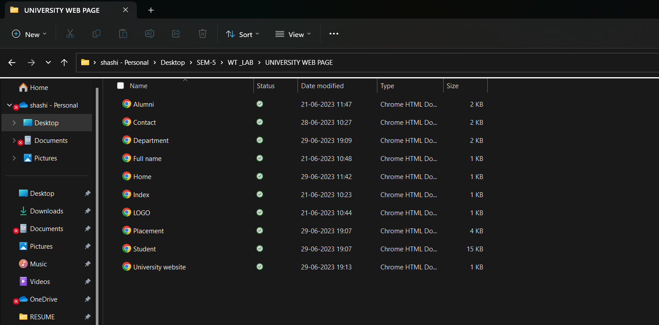

**CODE FOR UNIVERSITY WEB PAGE:**

<!DOCTYPE HTML>

<html>

<head>

<meta name="viewport" content="width=device-width, initial-scale=1.0">

<title> SHASHI KIRAN UNIVERSITY </title>

</head>

<body style="font-family: Arial, sans-serif; background-color:#88ff4d;">

<iframe name= "header" height ="77" width="13%" src="LOGO.html"></iframe>

<iframe name= "header" height ="77" width="86%" src="Full name.html"></iframe>

<iframe name= "left" height ="650" width="13%" src="Index.html"></iframe>

<iframe name= "right" height ="650" width="86%" src="C:\Users\sudan\OneDrive\Desktop\SEM-5\WT _LAB\UNIVERSITY WEB PAGE\Home.html"></iframe>

<p>NAME : SUDANA SHASHI KIRAN </p><br>

<p>REDG NUMBER : 21BCE8644 </p><br>

</body>

</html>

**This creates the frames of 4 as mentioned in below output:**  
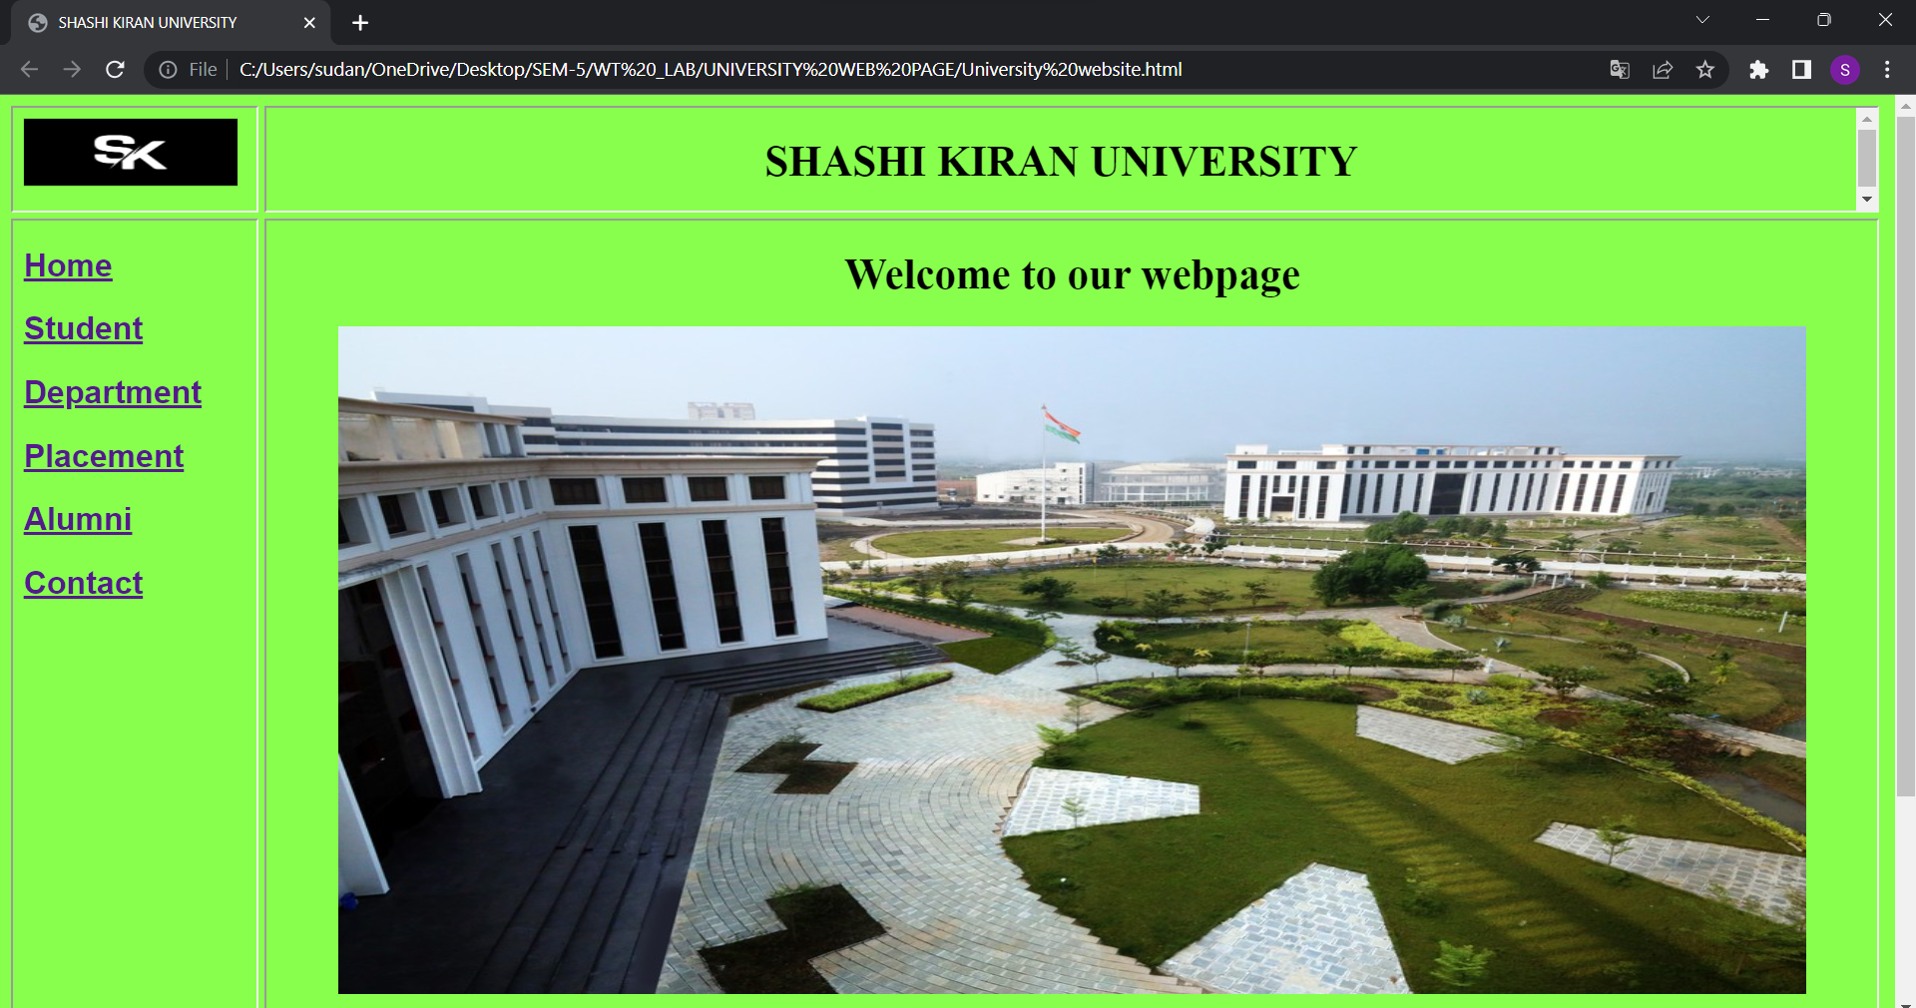

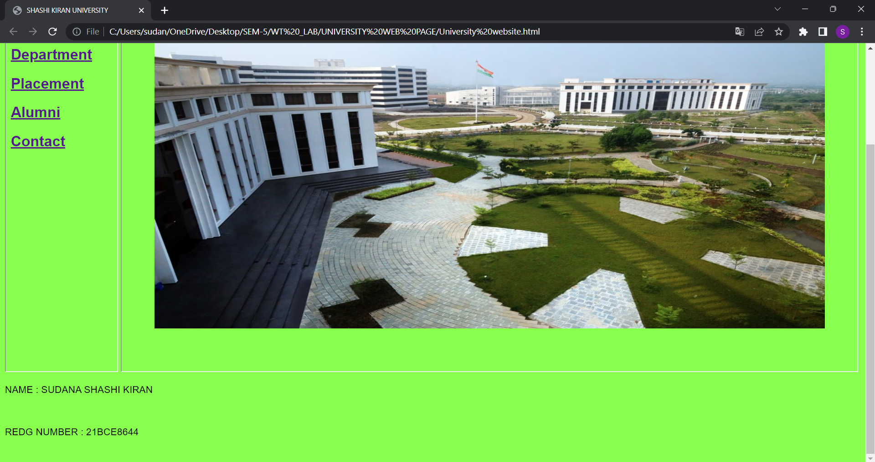

**CODE FOR HYPER LINKS (INDEX):**

<!DOCTYPE HTML>

<html>

<head>

<title> Index </title>

</head>

<body style="font-family: Arial, sans-serif; background-color:#88ff4d;">

<a href="Home.html"target="right">

<h2>Home</h2>

</a>

<a href="Student.html"target="right">

<h2>Student</h2>

</a>

<a href="Department.html"target="right">

<h2>Department</h2>

</a>

<a href="Placement.html"target="right">

<h2>Placement</h2>

</a>

<a href="Alumni.html"target="right">

<h2>Alumni</h2>

</a>

<a href="Contact.html"target="right">

<h2>Contact</h2>

</a>

</body>

<p>NAME : SUDANA SHASHI KIRAN </p>

<p>REDG NUMBER : 21BCE8644 </p><br>

</html>

**OUTPUT:**

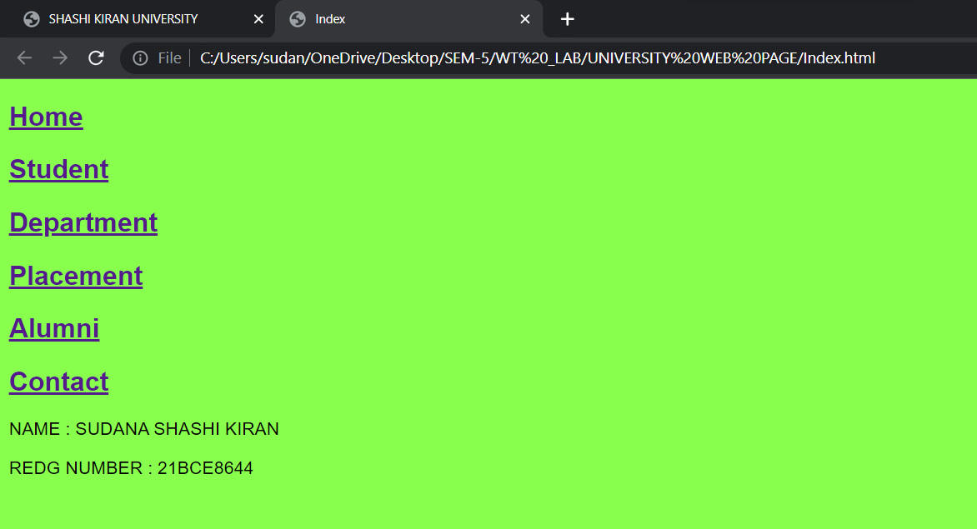

**CODE FOR HOME PAGE :**

<!DOCTYPE HTML>

<html>

<head>

<title> Index </title>

</head>

<body style="font-family: Arial, sans-serif; background-color:#88ff4d;">

<center>

<p>

<h1>Welcome to our webpage</h1>

</p>

<img src="C:\Users\sudan\Downloads\VIT-AP_Arial_View.jpg" alt="Placements" style="width:1100px;height:500px;">

</center>

</body>

<p>NAME : SUDANA SHASHI KIRAN </p>

<p>REDG NUMBER : 21BCE8644 </p><br>

</html>

**Screenshot for home page:**

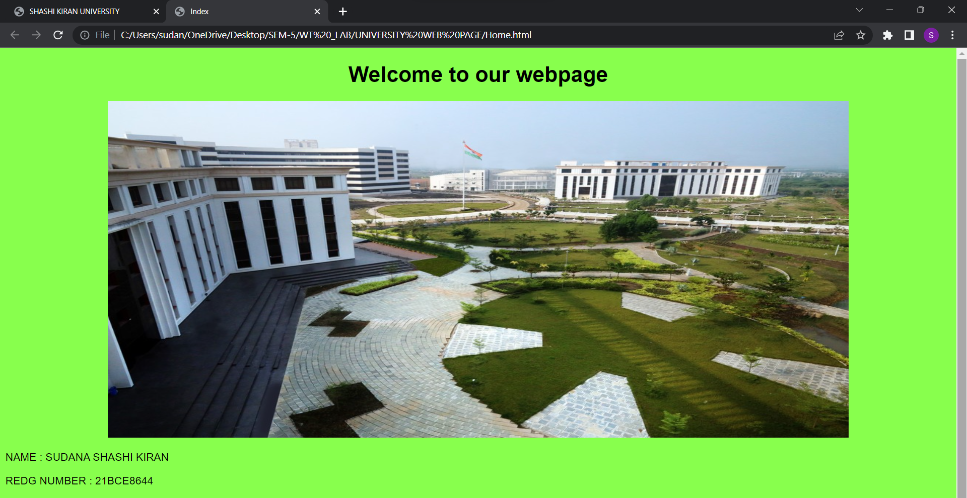

**CODE FOR STUDENT PAGE:**<html>

<head>

</head>

<body style="font-family: Arial, sans-serif; background-color:#88ff4d;">

<h1>CLUBS & CHAPTERS</h1>

At SK university, we believe in fostering an enriching environment where you are enabled to explore your creative selves and take pride in the work you do.

SK university features an array of clubs and chapters which offer you a life beyond academics.Our clubs and chapters provide a recreational space to explore creativity, make new friendships, engage in collaborative work, relax, and socialise. Various club activities eventually lead you to develop a crucial skillset comprising team-work, leadership, and event management. At present, there are more than 70 clubs in the university which include.

<h2>Technical clubs</h2>

<table>

<tr>

<th>Club Name</th>

</tr>

<tr>

<td>Android Club</td>

<td></td>

</tr>

<tr>

<td>BaN Club</td>

<td></td>

</tr>

<tr>

<td>A Blockchain Club</td>

<td></td>

</tr>

<tr>

<td>Creation Club</td>

<td></td>

</tr>

<tr>

<td>L.I.T – Data Analytics Club</td>

<td></td>

</tr>

<tr>

<td>Drushya- Animation and Gaming Club</td>

<td></td>

</tr>

<tr>

<td>Electronics Hobby Club (EHC)</td>

<td></td>

</tr>

<tr>

<td>IOT REVOLUTION – VIT-AP</td>

<td></td>

</tr>

<tr>

<td>Teach Your Machine Club – Machine Learning (TYMC)</td>

<td></td>

</tr>

<tr>

<td>PHOTON</td>

<td></td>

</tr>

<tr>

<td>Renewable Energy Club</td>

<td></td>

</tr>

<tr>

<td>RoboVIT-Robotics Club</td>

<td></td>

</tr>

<tr>

<td>Computer Society of India</td>

<td></td>

</tr>

<tr>

<td>IEEE Student Branch VIT-AP</td>

<td></td>

</tr>

<tr>

<td>Google Developers Student Club (GDSC VIT-AP)</td>

<td></td>

</tr>

<tr>

<td>Linux/Opensource</td>

<td></td>

</tr>

<tr>

<td>NULL Chapter</td>

<td></td>

</tr>

<tr>

<td>Cloud Computing</td>

<td></td>

</tr>

<tr>

<td>ACM Student-Chapter VIT-AP</td>

<td></td>

</tr>

<tr>

<td>Students for the Exploration and Development of Space (SEDS)</td>

<td></td>

</tr>

<tr>

<td>GPU Users Group (GPUG)</td>

<td></td>

</tr>

<tr>

<td>Code Chef VITAP Chapter</td>

<td></td>

</tr>

<tr>

<td>Microsoft Student Chapter</td>

<td></td>

</tr>

<tr>

<td>Oasis</td>

<td></td>

</tr>

<tr>

<td>HMOS Club</td>

<td></td>

</tr>

<tr>

<td>Women in Open Source (WiOS)</td>

<td></td>

</tr>

<tr>

<td>Academic & Industrial Nano Society (AINS)</td>

<td></td>

</tr>

<tr>

<td>FLY YOUR IDEAS (FYI) – DRONE CLUB</td>

<td></td>

</tr>

<tr>

<td>Electric Vehicle Club (SPARK)</td>

<td></td>

</tr>

<tr>

<td>Vikranth</td>

<td></td>

</tr>

<tr>

<td>Matlab Club</td>

<td></td>

</tr>

<tr>

<td>ASHRE</td>

<td></td>

</tr>

<tr>

<td>SAE</td>

<td></td>

</tr>

<tr>

<td>MTT IEEE Chapter</td>

<td></td>

</tr>

<tr>

<td>IET</td>

<td></td>

</tr>

<tr>

<td>Milestone Club</td>

<td></td>

</tr>

</table>

<h2>Non-Technical clubs</h2>

<table>

<tr>

<th>Club Name</th>

</tr>

<tr>

<td>Adventure Club</td>

<td></td>

</tr>

<tr>

<td>Movie Making and Screening Club</td>

<td></td>

</tr>

<tr>

<td>Youtuber Club</td>

<td></td>

</tr>

<tr>

<td>Bulls and Bears (Financial Management)</td>

<td></td>

</tr>

<tr>

<td>Indian Classical Music Club</td>

<td></td>

</tr>

<tr>

<td>Clean Campus Club- Swachh</td>

<td></td>

</tr>

<tr>

<td>Stand Up Comedy Club (Jigujaa)</td>

<td></td>

</tr>

<tr>

<td>Sanskriti Club</td>

<td></td>

</tr>

<tr>

<td>Beat The Heat – Dance Club</td>

<td></td>

</tr>

<tr>

<td>Dhwani-Theatre & Fine Arts Club</td>

<td></td>

</tr>

<tr>

<td>Do It Yourself (DIY) Club</td>

<td></td>

</tr>

<tr>

<td>The Gardening Club</td>

<td></td>

</tr>

<tr>

<td>KNIT Club</td>

<td></td>

</tr>

<tr>

<td>LIVIT</td>

<td></td>

</tr>

<tr>

<td>Math Club</td>

<td></td>

</tr>

<tr>

<td>Western Music Club</td>

<td></td>

</tr>

<tr>

<td>News Paper Club</td>

<td></td>

</tr>

<tr>

<td>SPIC MACAY Heritage Club Syllabus</td>

<td></td>

</tr>

<tr>

<td>National Service Scheme</td>

<td></td>

</tr>

<tr>

<td>CHAITRA TELUGU ASSOCIATION</td>

<td></td>

</tr>

<tr>

<td>TAMIL ASSOCIATION</td>

<td></td>

</tr>

<tr>

<td>HINDI ASSOCIATION</td>

<td></td>

</tr>

<tr>

<td>ODIA ASSOCIATION</td>

<td></td>

</tr>

<tr>

<td>MALAYALAM ASSOCIATION</td>

<td></td>

</tr>

<tr>

<td>BENGALI ASSOCIATION</td>

<td></td>

</tr>

<tr>

<td>English Literary Association</td>

<td></td>

</tr>

<tr>

<td>Click ‘n’ Flick Photography Club</td>

<td></td>

</tr>

<tr>

<td>QUIZ Club</td>

<td></td>

</tr>

<tr>

<td>Run 4 a Cause (Students & Faculty)</td>

<td></td>

</tr>

<tr>

<td>SEED Club</td>

<td></td>

</tr>

<tr>

<td>Sports Club</td>

<td></td>

</tr>

<tr>

<td>Toastmasters Club</td>

<td></td>

</tr>

<tr>

<td>Uddeshya VIT-AP</td>

<td></td>

</tr>

<tr>

<td>Around the World</td>

<td></td>

</tr>

<tr>

<td>BookBuzz</td>

<td></td>

</tr>

<tr>

<td>Cooking / Culinary Club</td>

<td></td>

</tr>

<tr>

<td>VITonomics</td>

<td></td>

</tr>

<tr>

<td>Innovators Quest (I-Quest)</td>

<td></td>

</tr>

<tr>

<td>Kalki- Personal development club (KPDC)</td>

<td></td>

</tr>

<tr>

<td>Melange - Inspire. Attract. Trend</td>

<td></td>

</tr>

<tr>

<td>MUN club</td>

<td></td>

</tr>

<tr>

<td>Nutrition Club</td>

<td></td>

</tr>

<tr>

<td>Rudra Club-Open Community</td>

<td></td>

</tr>

<tr>

<td>Think and Thrive</td>

<td></td>

</tr>

<tr>

<td>Youth Empowerment and skills (Yes+!)</td>

<td></td>

</tr>

<tr>

<td>Kuge Gemu Clan</td>

<td></td>

</tr>

<tr>

<td>Pennify VIT-AP chapter</td>

<td></td>

</tr>

<tr>

<td>Otaka Haven Club</td>

<td></td>

</tr>

<tr>

<td>Climate Change Club</td>

<td></td>

</tr>

<tr>

<td>TEDX_VITAP</td>

<td></td>

</tr>

<tr>

<td>Rotaract</td>

<td></td>

</tr>

<tr>

<td>College Radio</td>

<td></td>

</tr>

<tr>

<td>Kannada Club</td>

<td></td>

</tr>

<tr>

<td>Marathi Association</td>

<td></td>

</tr>

<tr>

<td>BizzDom Club</td>

<td></td>

</tr>

</table>

<h2>Regional clubs & chapters<h2>

<table>

<tr>

<th>Club</th>

</tr>

<tr>

<td>SPIC MACAY Heritage Club Syllabus</td>

<td></td>

</tr>

<tr>

<td>Computer Society of India</td>

<td></td>

</tr>

<tr>

<td>IEEE Student Branch VIT-AP</td>

<td></td>

</tr>

<tr>

<td>Google Developers Student Club (GDSC VIT-AP)</td>

<td></td>

</tr>

<tr>

<td>Linux/Opensource</td>

<td></td>

</tr>

<tr>

<td>NULL Chapter</td>

<td></td>

</tr>

<tr>

<td>ACM Student- Chapter VIT-AP</td>

<td></td>

</tr>

<tr>

<td>Students for the Exploration and Development of Space (SEDS)</td>

<td></td>

</tr>

<tr>

<td>Code Chef VITAP Chapter</td>

<td></td>

</tr>

<tr>

<td>Microsoft Student Chapter</td>

<td></td>

</tr>

<tr>

<td>HMOS Club</td>

<td></td>

</tr>

<tr>

<td>Women in Open Source (WiOS)</td>

<td></td>

</tr>

<tr>

<td>Pennify VIT-AP chapter</td>

<td></td>

</tr>

<tr>

<td>IEEE (Women in Engineering)</td>

<td></td>

</tr>

<tr>

<td>TEDX_VITAP</td>

<td></td>

</tr>

<tr>

<td>Matlab Club</td>

<td></td>

</tr>

<tr>

<td>Rotaract</td>

<td></td>

</tr>

<tr>

<td>ASHRE</td>

<td></td>

</tr>

<tr>

<td>SAE</td>

<td></td>

</tr>

<tr>

<td>MTT IEEE Chapter</td>

<td></td>

</tr>

<tr>

<td>IET</td>

<td></td>

</tr>

<tr>

<td>Milestone Club</td>

<td></td>

</tr>

<tr>

<td>CHAITRA TELUGU ASSOCIATION</td>

<td></td>

</tr>

<tr>

<td>TAMIL ASSOCIATION</td>

<td></td>

</tr>

<tr>

<td>हिंदी एसोसिएशन (Hindi Association)</td>

<td></td>

</tr>

<tr>

<td>ODIA ASSOCIATION</td>

<td></td>

</tr>

<tr>

<td>MALAYALAM ASSOCIATION</td>

<td></td>

</tr>

<tr>

<td>BENGALI ASSOCIATION</td>

<td></td>

</tr>

<tr>

<td>English Literary Association</td>

<td></td>

</tr>

<tr>

<td>Kannada Club</td>

<td></td>

</tr>

<tr>

<td>Amhi Marathi Association</td>

<td></td>

</tr>

</table>

<img src="C:\Users\sudan\Downloads\CSI.jpg" alt=" B TECH" width="350" height="250"<p>&emsp;&emsp;&emsp;CSI CLUB</p>

<img src="C:\Users\sudan\Downloads\ANDROID.jpg" alt=" B TECH" width="350" height="250"<p>&emsp;&emsp;&emsp;ANDROID CLUB</p>

<img src="C:\Users\sudan\Downloads\DIY.jpg" alt=" B TECH" width="350" height="250"<p>&emsp;&emsp;&emsp;DIY CLUB</p>

<img src="C:\Users\sudan\Downloads\DRUSHYA.jpg" alt=" B TECH" width="350" height="250"<p>&emsp;&emsp;&emsp;DRUSHYA CLUB</p>

<img src="C:\Users\sudan\Downloads\MUSIC.jpg" alt=" B TECH" width="350" height="250"<p>&emsp;&emsp;&emsp;MUSIC CLUB</p>

<img src="C:\Users\sudan\Downloads\DANCE.jpg" alt=" B TECH" width="350" height="250"<p>&emsp;&emsp;&emsp;DANCE CLUB</p>

<img src="C:\Users\sudan\Downloads\MATHS.jpg" alt=" B TECH" width="350" height="250"<p>&emsp;&emsp;&emsp;MATHS CLUB</p>

<h1>Sports at VIT-AP</h1>

<h2>About Sports at VIT-AP</h2>

<p>At SK, we believe that sound mental and good physical health are crucial for holistic development. With a strong emphasis on recreation, we provide facilities that keep our students, faculty, and staff active, spirited, involved, and healthy. We organize several intramural sports events, including cricket, badminton, volleyball, chess, and more. Additionally, we host the in-house Sports and Cultural fest VITopia where different colleges and universities participate.</p>

<h2>International Karate Championship</h2>

<p>Our university students (boys & girls) participated in the 4th International Karate Championship held from 31/01/2020 to 02/02/2020 at Rajivgandhi Port Stadium Visakhapatnam, organized by the UNITED SHOTOKAN KARATE-DO INDIA. Over 700 contestants participated in various categories. We are proud to announce that our team won a total of 13 medals.</p>

<h2>Medal Winners</h2>

<table class="medal-table">

<tr>

<th>Name</th>

<th>Medal (Category)</th>

</tr>

<tr>

<td>Mridul Jain</td>

<td>2 bronze (kata and kumite)</td>

</tr>

<tr>

<td>Yogesh Mudgul</td>

<td>1 bronze (kumite)</td>

</tr>

<tr>

<td>Nitin Garg</td>

<td>1 silver (kumite)</td>

</tr>

<tr>

<td>Charani Kavali</td>

<td>1 bronze (kata), 1 silver (kumite)</td>

</tr>

<tr>

<td>Vaishnavi Singu</td>

<td>1 gold (kata), 1 silver (kumite)</td>

</tr>

<tr>

<td>Keerthana.A</td>

<td>1 bronze (kumite)</td>

</tr>

<tr>

<td>Srishti</td>

<td>1 bronze (kumite)</td>

</tr>

<tr>

<td>Stotra Anubhav</td>

<td>1 bronze (kumite)</td>

</tr>

<tr>

<td>Riddhi Parekh</td>

<td>1 gold (kumite), 1 bronze (kata)</td>

</tr>

</table>

<img src="C:\Users\sudan\Downloads\SPORTS 1.jpg" alt=" B TECH" width="350" height="250"<p>&emsp;&emsp;&emsp;Cricket</p>

<img src= "C:\Users\sudan\Downloads\SPORTS 2.jpg" alt=" B TECH" width="350" height="250"<p>&emsp;&emsp;&emsp;Chess</p>

<img src="C:\Users\sudan\Downloads\SPORTS 3.jpg" alt=" B TECH" width="350" height="250"<p>&emsp;&emsp;&emsp;Winners in international level</p>

<img src="C:\Users\sudan\Downloads\SPORTS 4.jpg" alt=" B TECH" width="350" height="250"<p>&emsp;&emsp;&emsp; Volley ball</p>

<strong>Here are som videos of sports played in our university</strong><br>

<video width="900" height="550" controls>

<source src="C:\Users\sudan\Downloads\SPORTS.mp4" type="video/mp4">

<source src="C:\Users\sudan\Downloads\SPORTS.ogg" type="video/ogg">

</video>

<video width="900" height="550" controls>

<source src="C:\Users\sudan\Downloads\SPORTS_!.mp4" type="video/mp4">

<source src="C:\Users\sudan\Downloads\SPORTS_!.ogg" type="video/ogg">

</video>

<h1>Hostels</h1>

The SK hostels are highly secure and well guarded. Only VITians & VIT authorized personnel are allowed inside. We aspire to make the hostel a ‘home away from home. Each hostel room is equipped with a cot, chair, study table and cupboard. Resident wardens are available 24×7. Provision stores are located in the hostel where students can buy essentials such as mattresses, pillows, buckets, mugs, locks, stationeries, books, soaps.

Both AC and Non-AC rooms are available. The type of room is allocated on the first-come first serve basis and availability once the hostel fee is paid in full.<br>

<img src="C:\Users\sudan\Downloads\HOSTELS 1.jpg" alt=" B TECH" width="350" height="250"<p>&emsp;&emsp;&emsp;LH 1</p>

<img src="C:\Users\sudan\Downloads\HOSTELS 2.jpg" alt=" B TECH" width="350" height="250"<p>&emsp;&emsp;&emsp;MH 3</p>

<img src="C:\Users\sudan\Downloads\HOSTELS 3.jpg" alt=" B TECH" width="350" height="250"<p>&emsp;&emsp;&emsp;MH 1 and MH 2</p>

<img src="C:\Users\sudan\Downloads\HOSTELS 4.jpg" alt=" B TECH" width="350" height="250"<p>&emsp;&emsp;&emsp;MH 4</p>

<strong>Video of our university</strong><br>

<video width="900" height="550" controls>

<source src="C:\Users\sudan\Downloads\UNIVERSITY _!.mp4" type="video/mp4">

<source src="C:\Users\sudan\Downloads\UNIVERSITY _!.ogg" type="video/ogg">

</video>

<p>NAME : SUDANA SHASHI KIRAN </p>

<p>REDG NUMBER : 21BCE8644 </p><br>

</body>

**THIS INCLUDED OF MANY PHOTOS AND VIDEOS IN THE STUDENT HYPER LINK**

**SCREENSHOT OF IT :**  
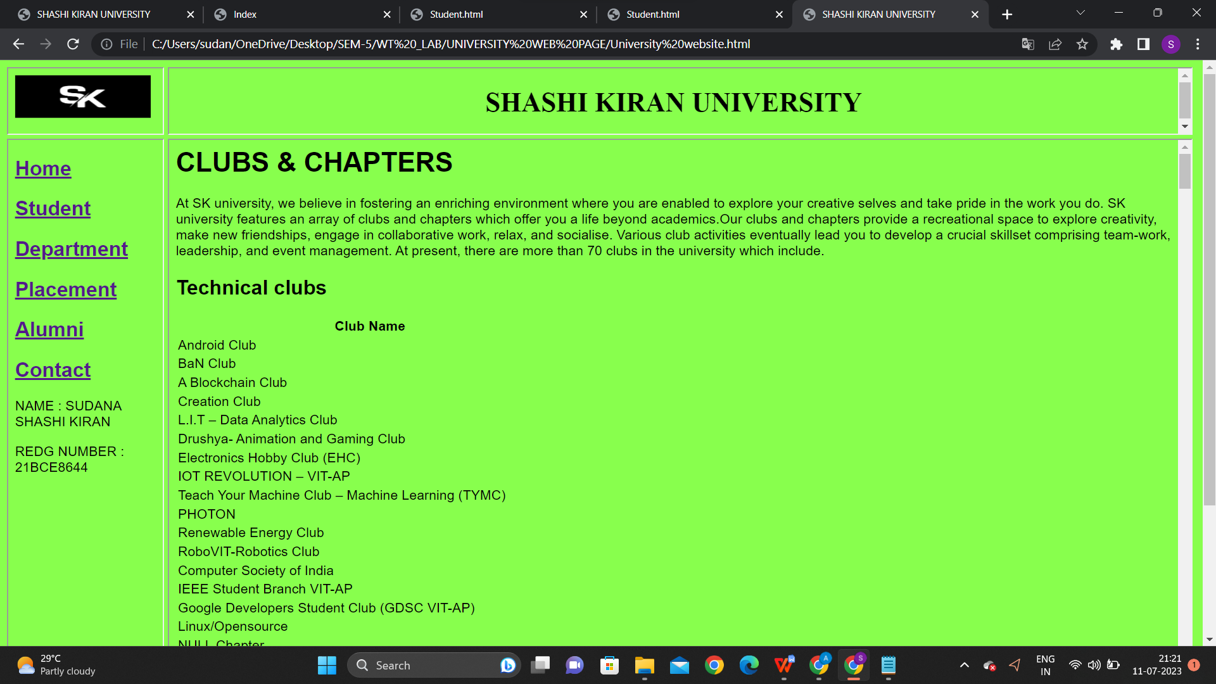

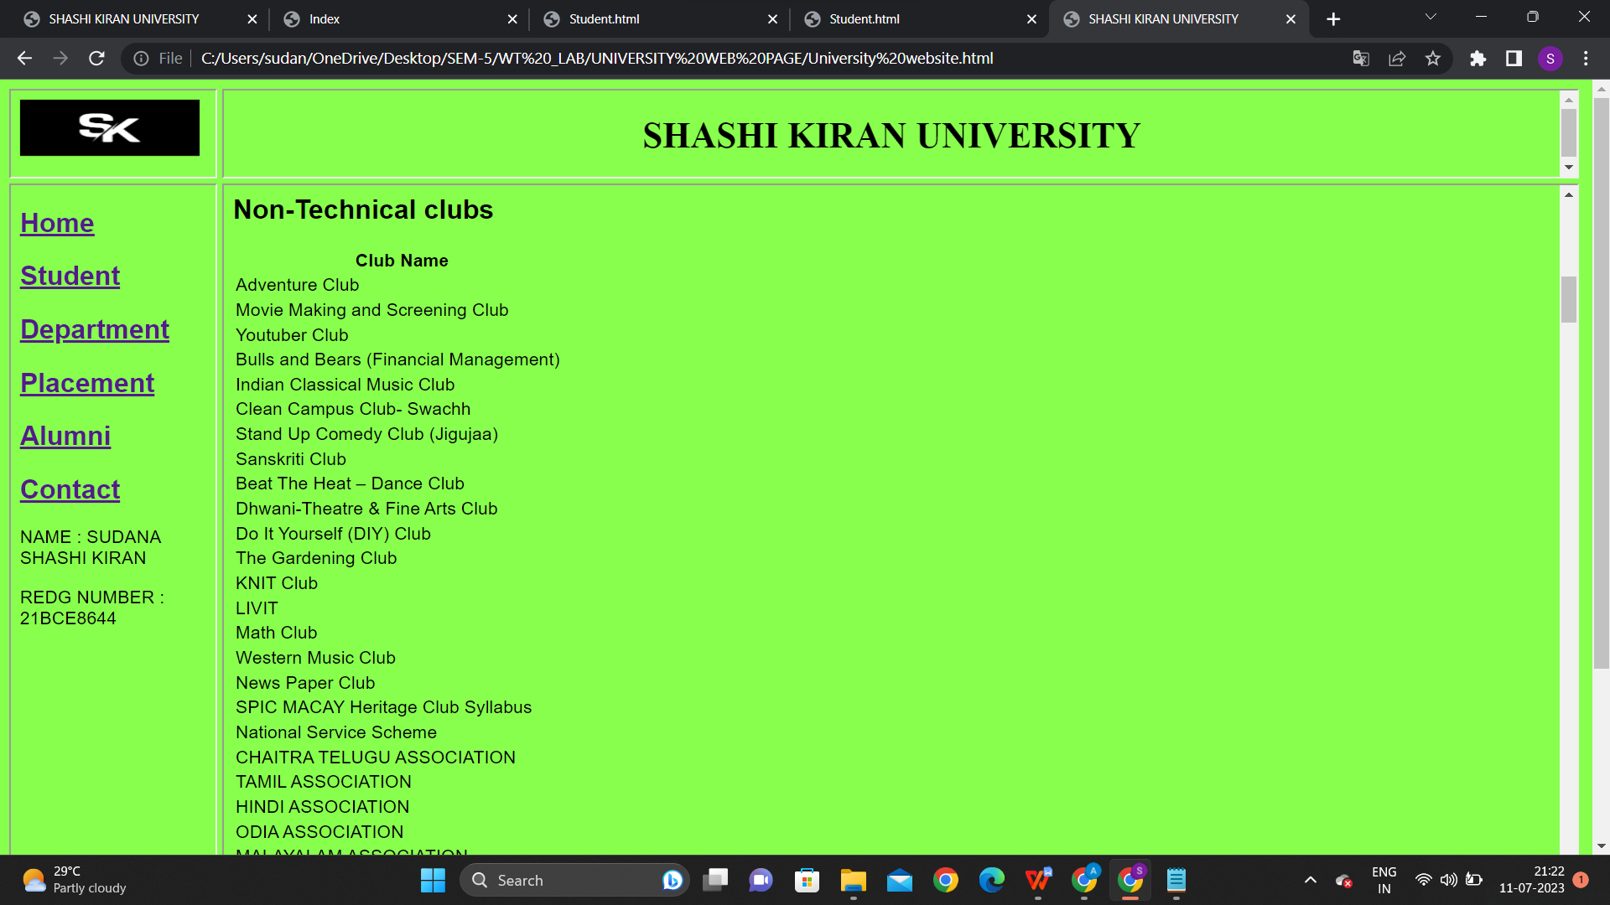

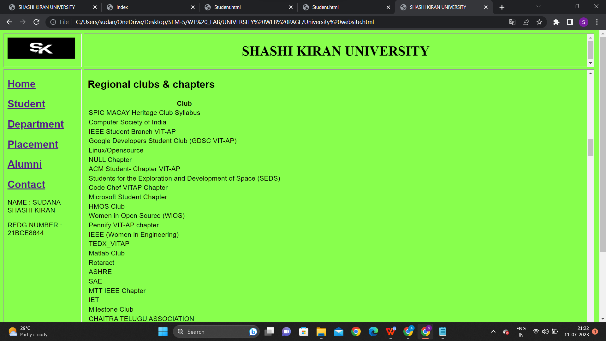

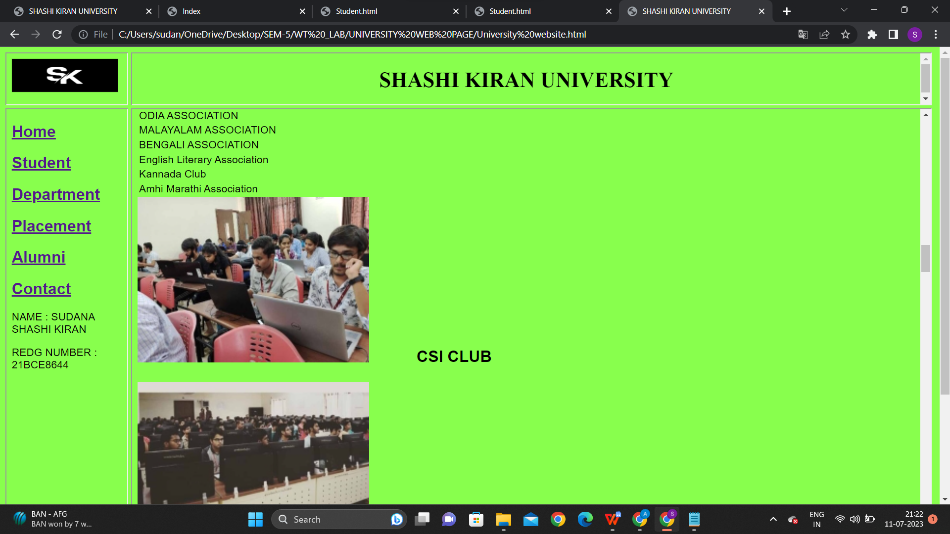

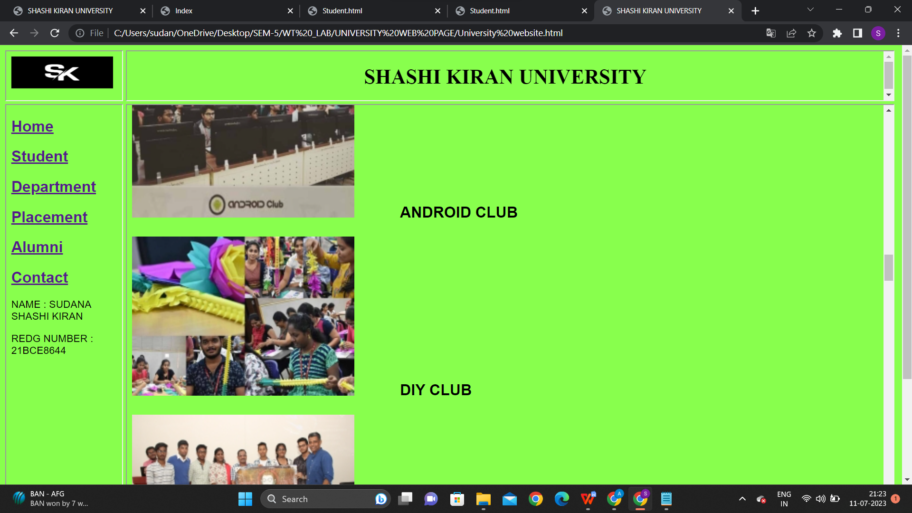

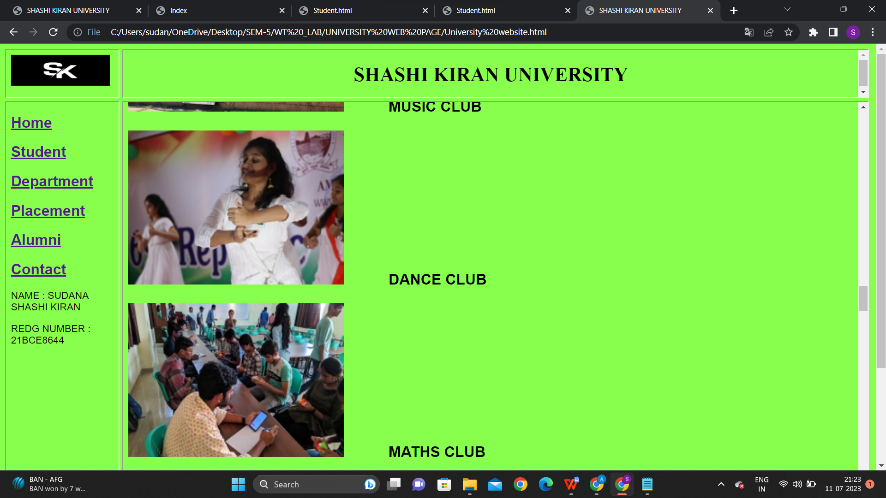

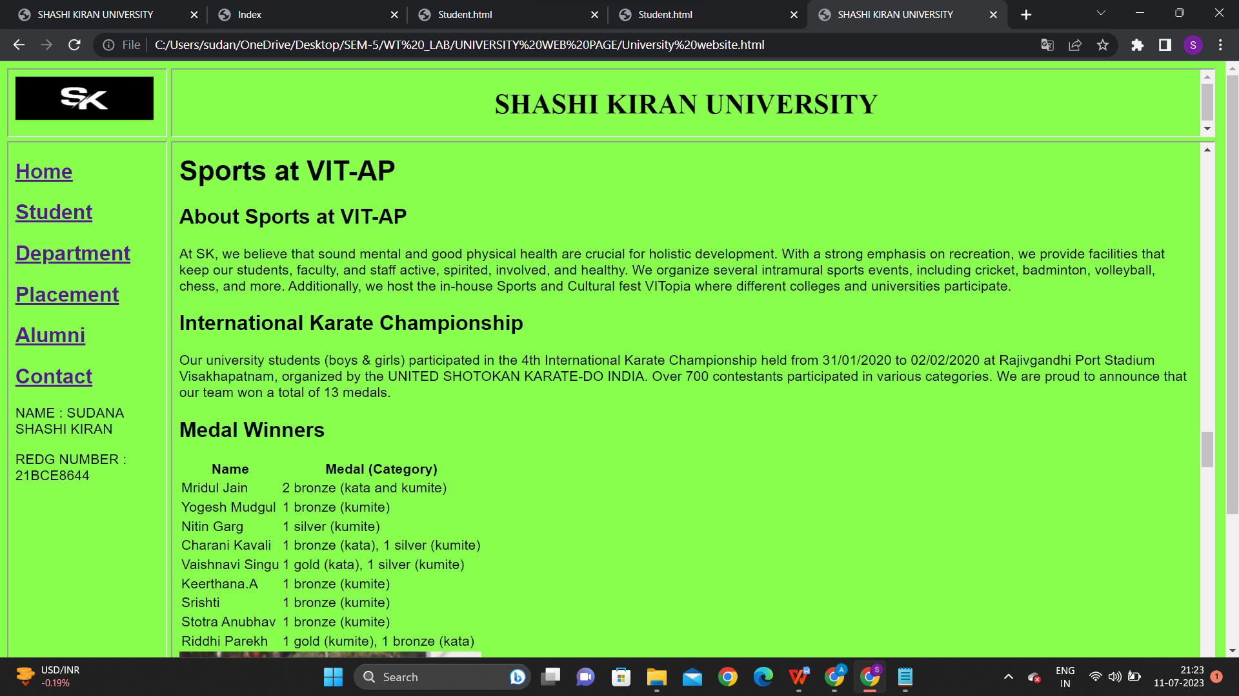

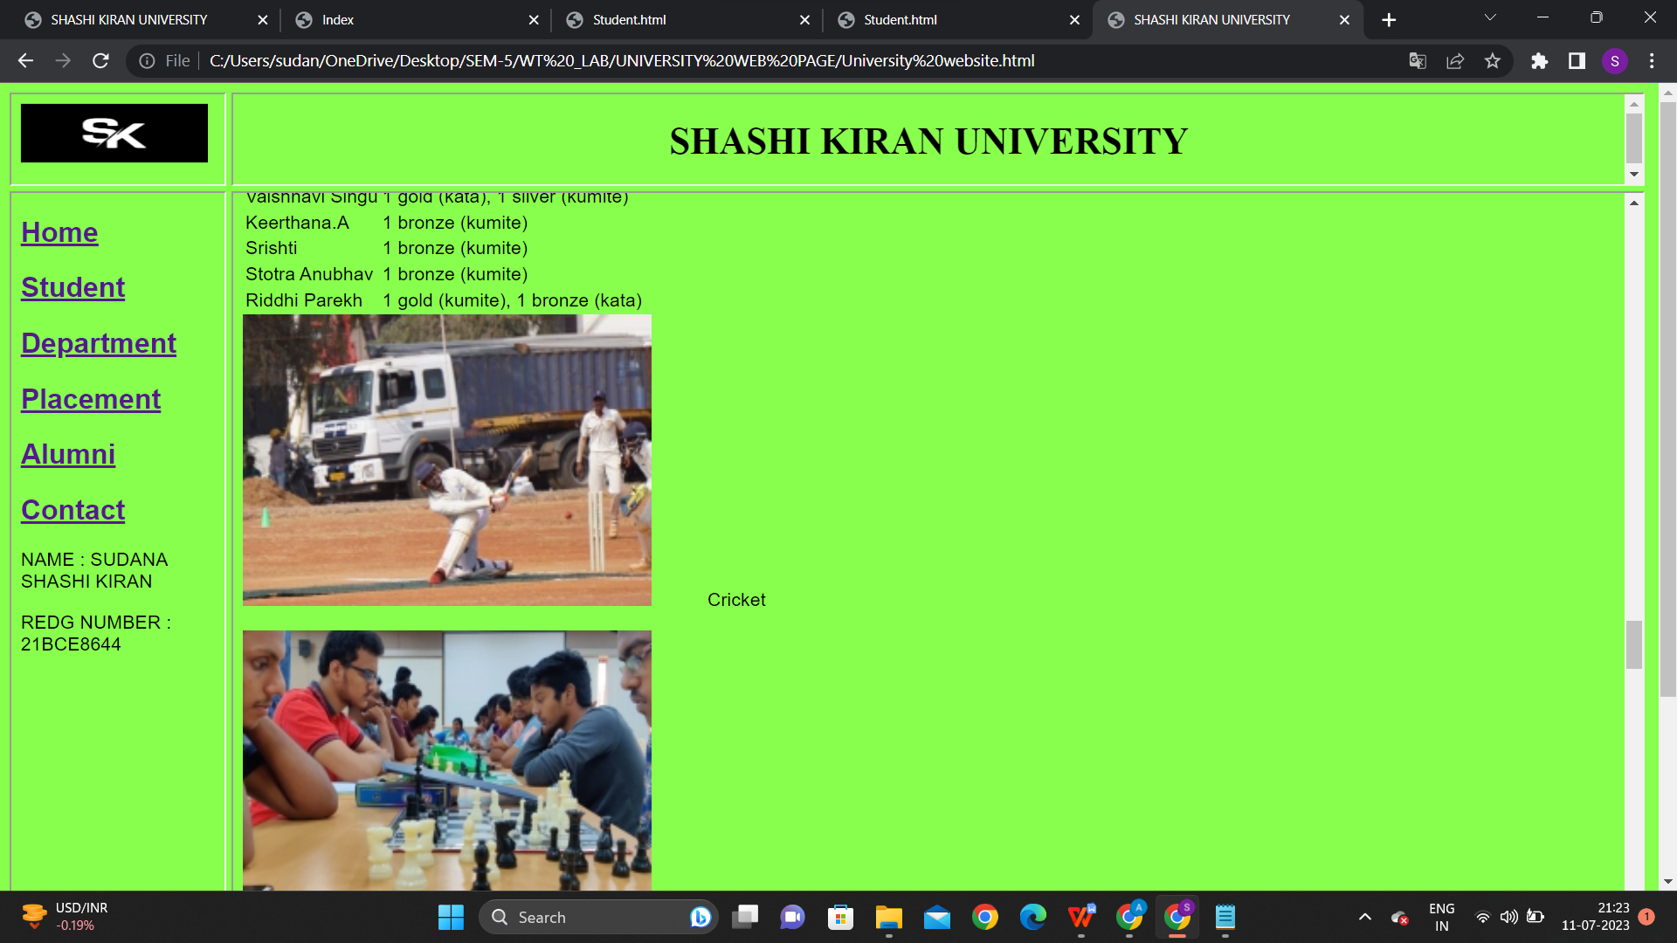

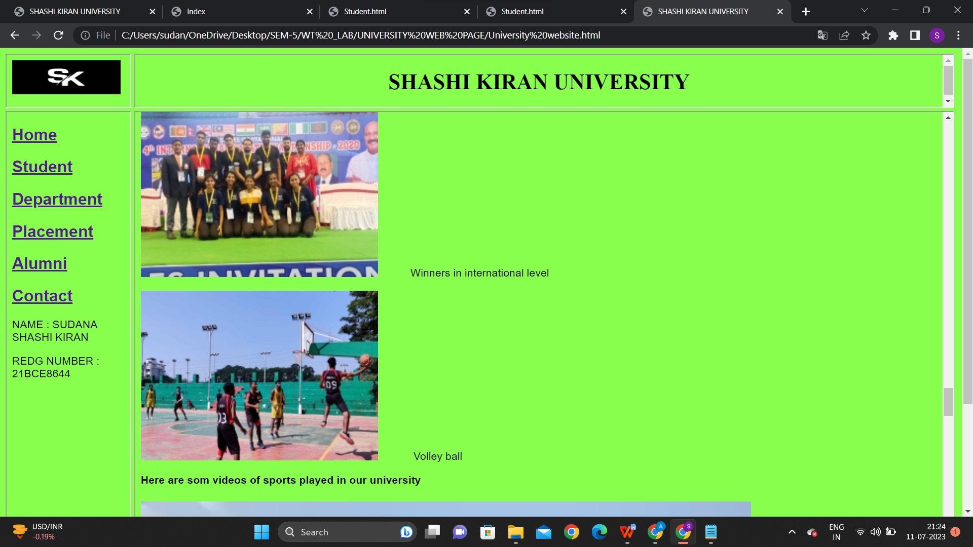

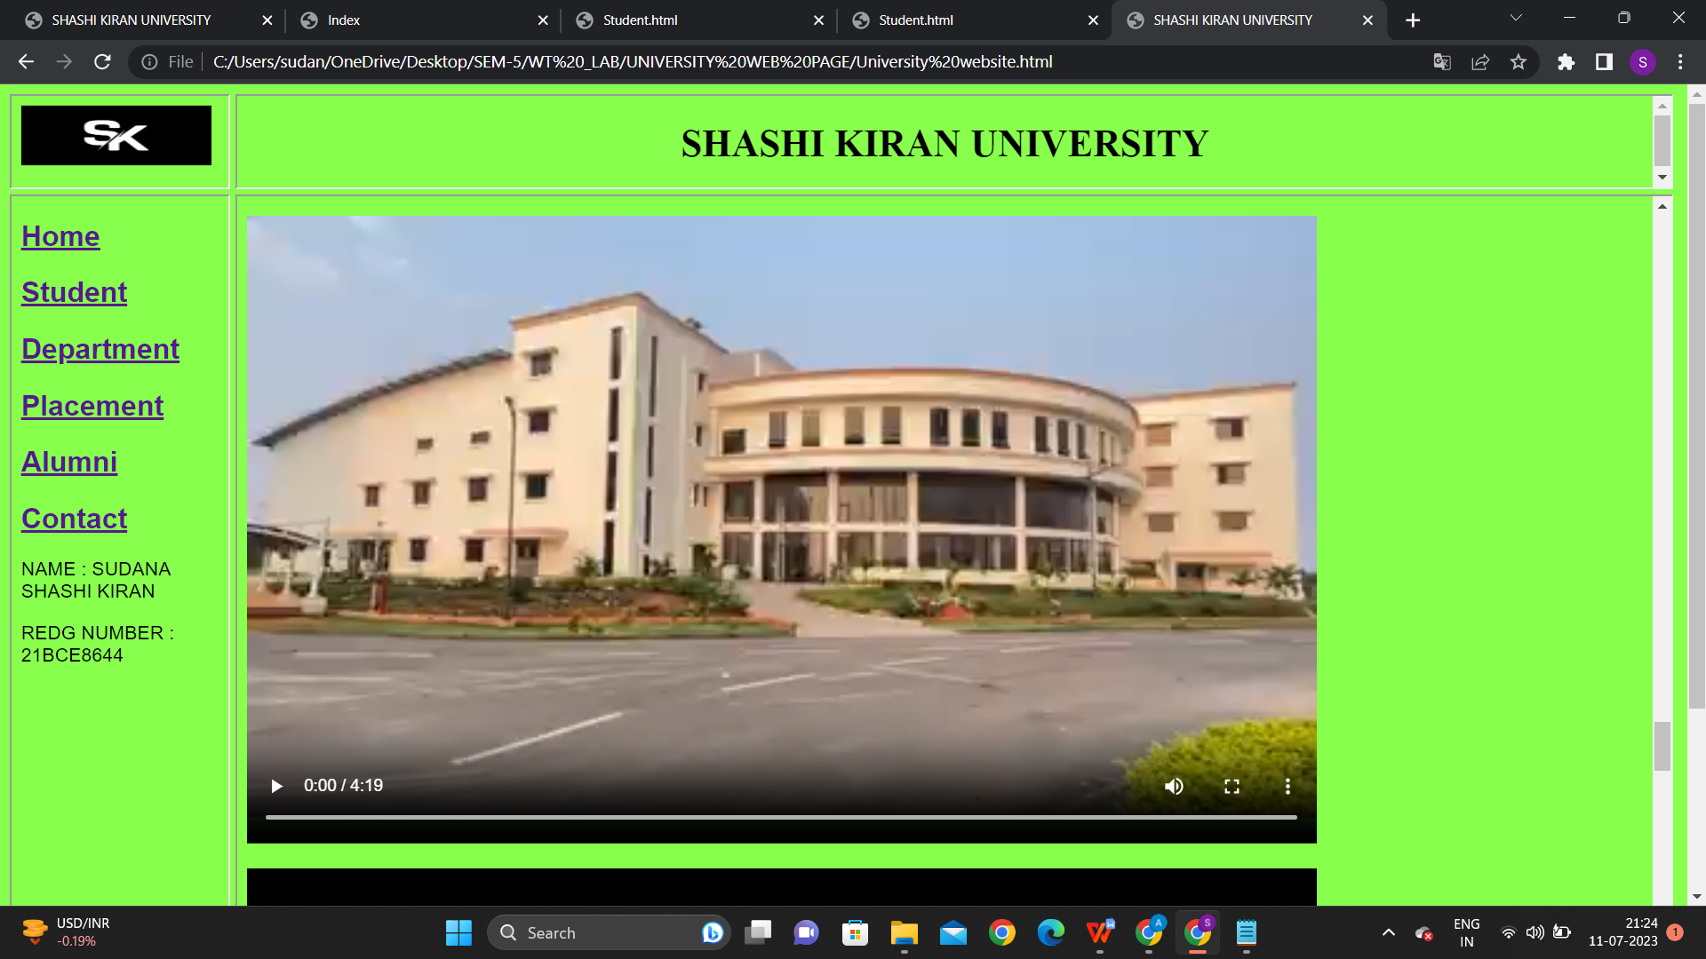

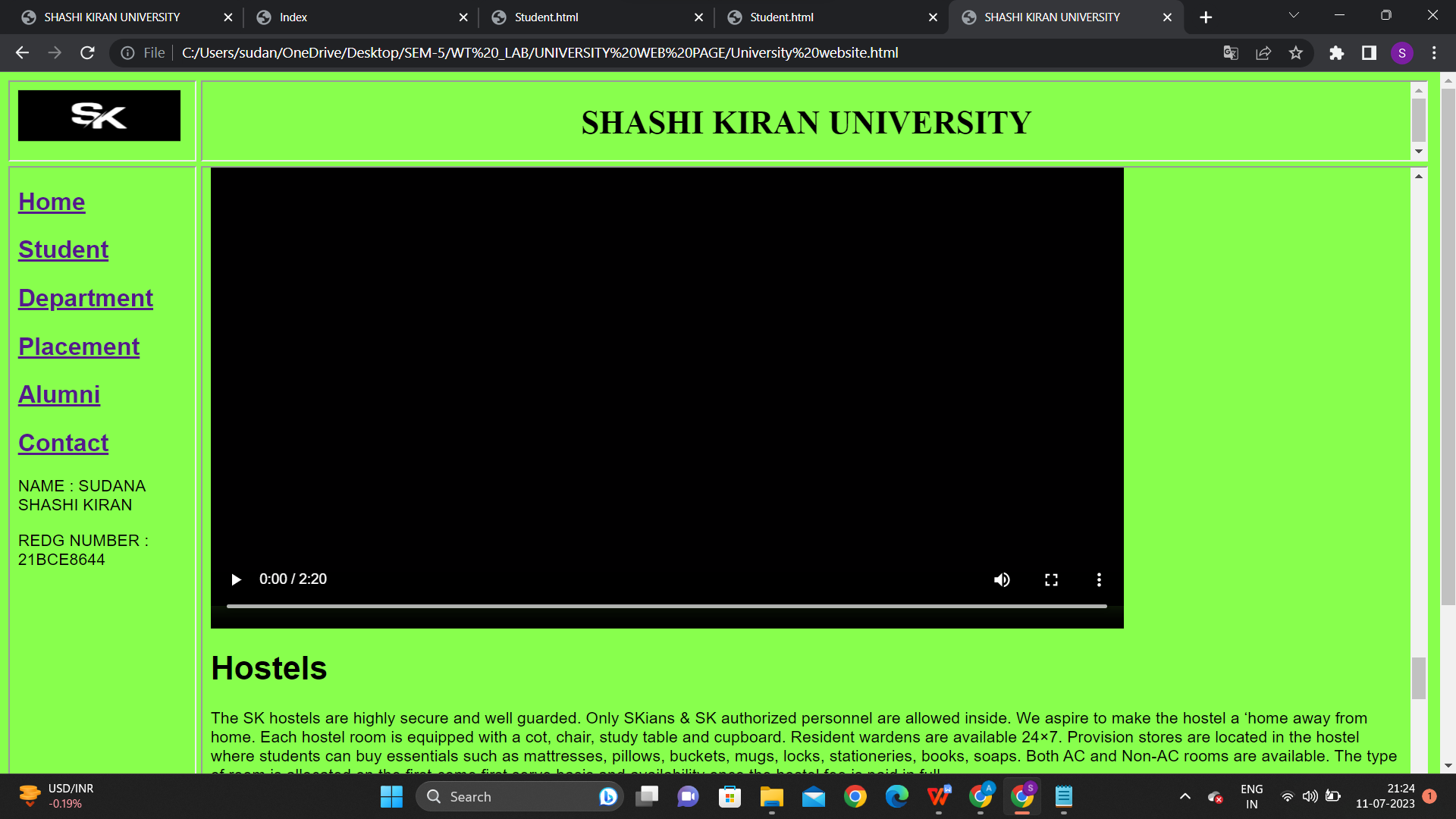

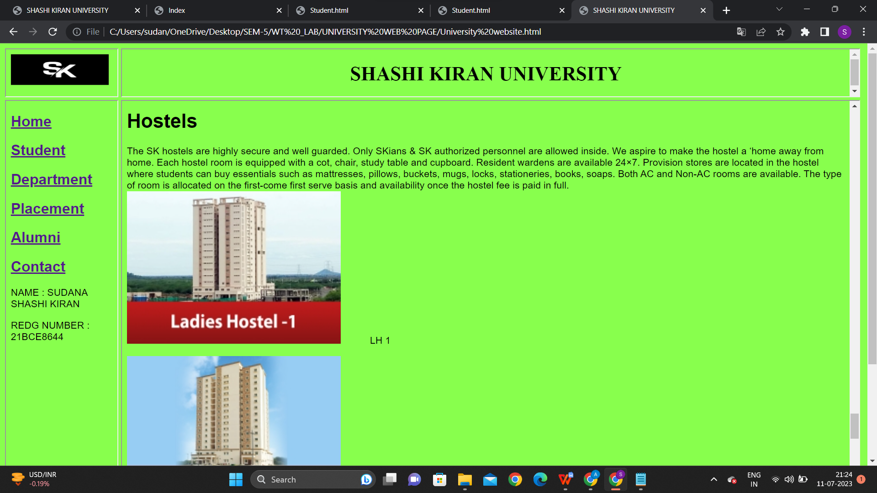

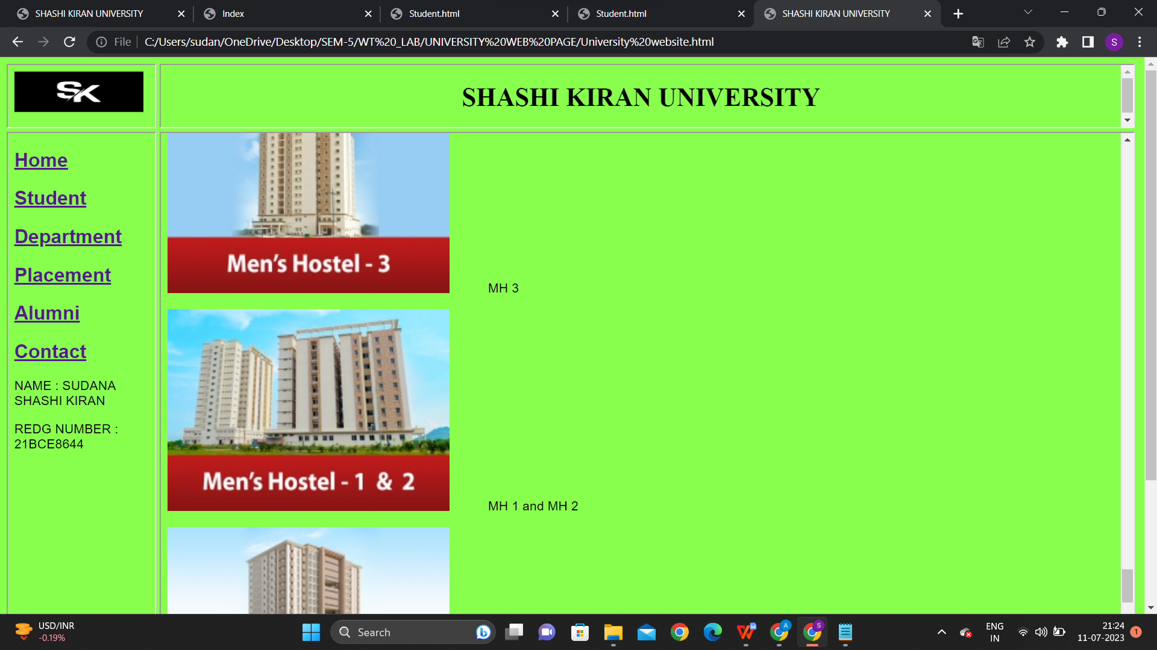

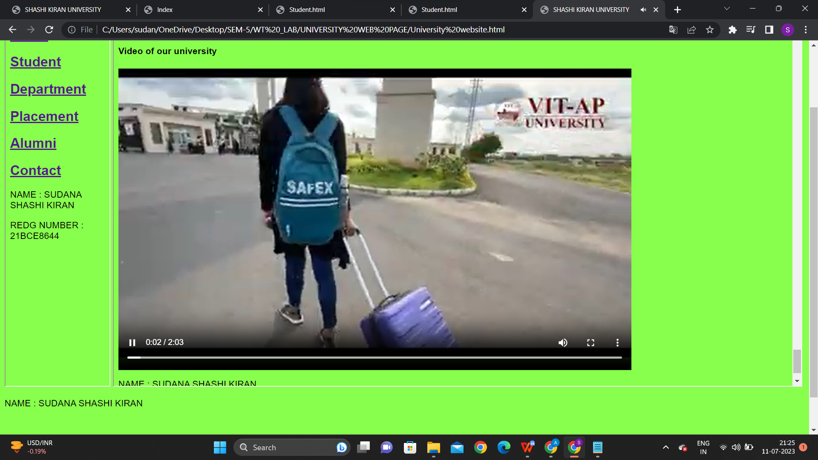

**HERE I INCLUDED 3 VIDEOS**

**CODE FOR DEPARTMENT HYPERLINK:**

<html>

<head>

<title>Department page</title>

</head>

<body style="font-family: Arial, sans-serif; background-color:#88ff4d;">

<h1>Departments in SK university</h1>

<p>SK university offers distinctive education through its Undergraduate, Postgraduate and Ph.D Programmes. The teaching-learning process at the institute prepares students for the future. They are involved in an active process of applied learning with the help of experienced faculty who enable the students to channel their talent and intellect to contribute towards the development and sustainability of society. With an emphasis on innovation and applying technology to improve life, the institute offers the following programmes for students at various levels.</p>

<img src="C:\Users\sudan\Downloads\b com 2.jpg" alt=" B TECH" width="550" height="250"<p>&emsp;&emsp;&emsp;B COM</p>

<img src="C:\Users\sudan\Downloads\b tech 2.jpeg.jpg" alt=" B TECH" width="550" height="250"<p>&emsp;&emsp;&emsp;BTCH</p>

<img src="C:\Users\sudan\Downloads\b tech.jpg" alt=" B TECH" width="550" height="250"<p>&emsp;&emsp;&emsp;BTECH/p>

<img src="C:\Users\sudan\Downloads\Mteh-Intragrated2.jpg" alt=" B TECH" width="550" height="250"<p>&emsp;&emsp;&emsp;MTech integrated</p>

<img src="C:\Users\sudan\Downloads\B.Sc.jpg" alt=" B TECH" width="550" height="250"<p>&emsp;&emsp;&emsp;B.Sc.</p>

<img src="C:\Users\sudan\Downloads\law 2.jpeg.jpg" alt=" B TECH" width="550" height="250"<p>&emsp;&emsp;&emsp;LAW</p>

<img src="C:\Users\sudan\Downloads\M.TECH.jpg" alt=" B TECH" width="650" height="250"<p>&emsp;&emsp;&emsp;M.TECH</p>

<img src="C:\Users\sudan\Downloads\Ph.D.jpg" alt=" B TECH" width="650" height="250"<p>&emsp;&emsp;&emsp;Ph.D</p>

</body>

<p>NAME : SUDANA SHASHI KIRAN </p>

<p>REDG NUMBER : 21BCE8644 </p><br>

</html>

**SCREENSHOTS:**

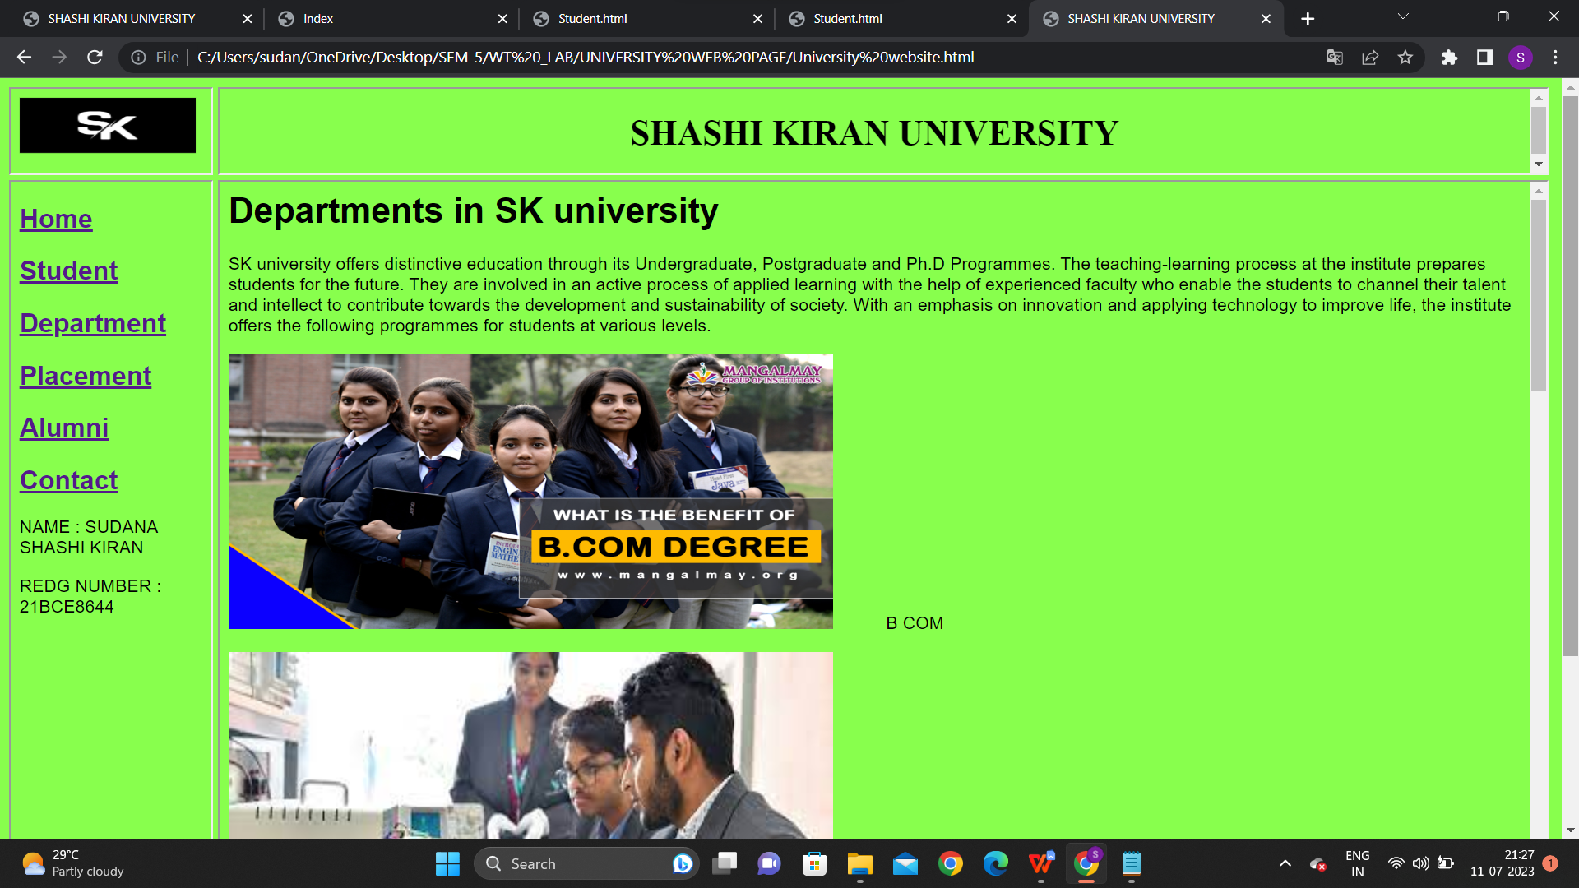

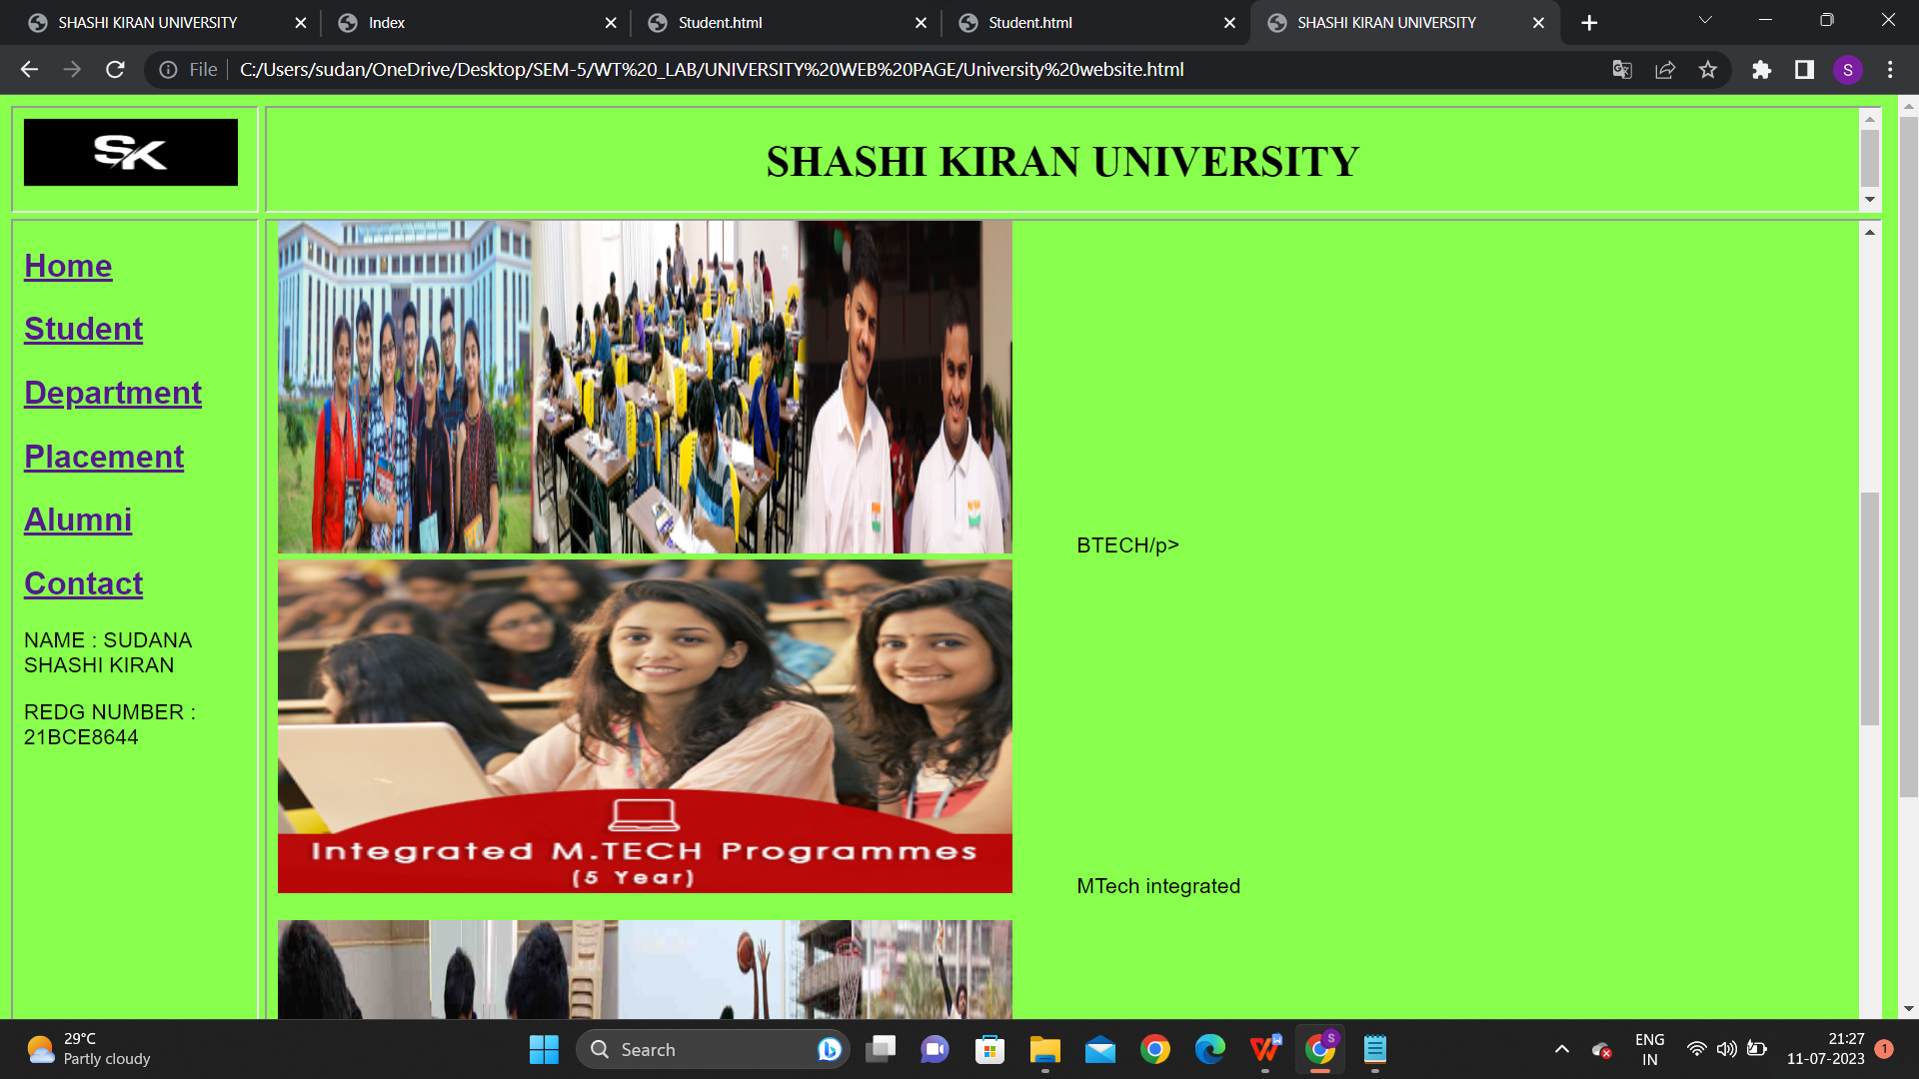

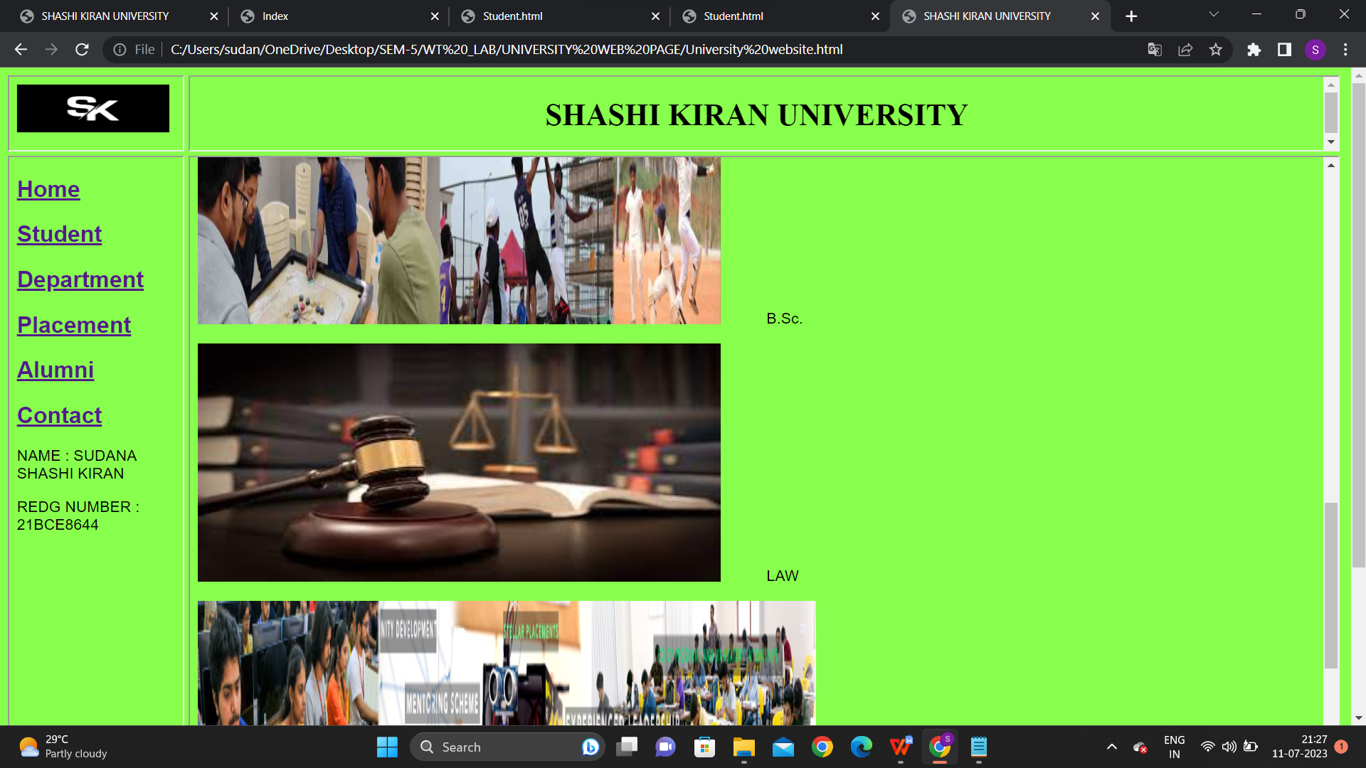

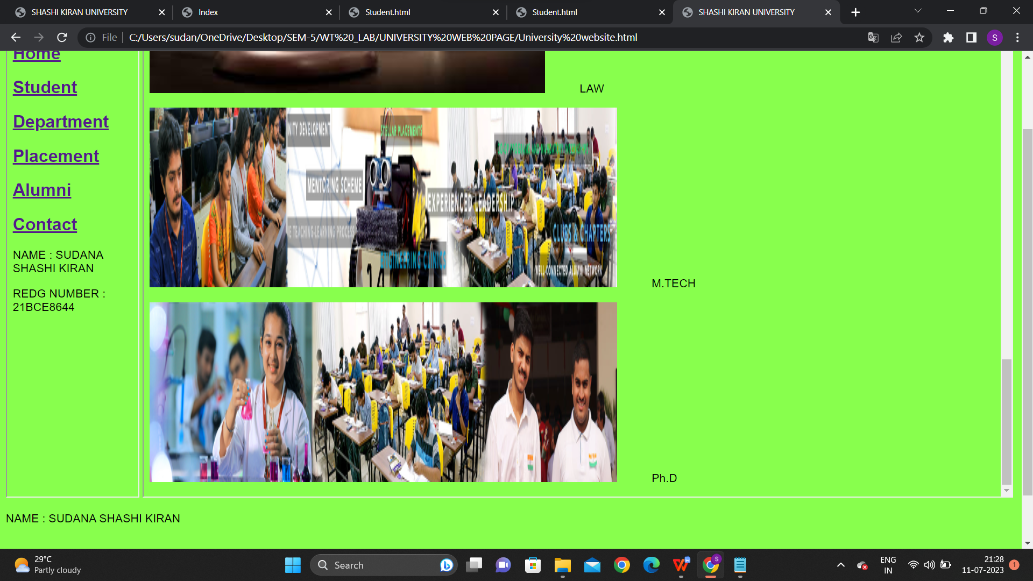

**CODE FOR PLACEMENT HYPERLINK :**

<html>

<head>

<title>Placement page</title>

</head>

<h1>Placements in our university</h1>

<body style="font-family: Arial, sans-serif; background-color:#88ff4d;">

<p>In Dream placement offer, 3836 students are presented with offers with Cost of Company (CTC) of 5.5 Lakhs and above per annum. More than 386 companies have been giving this placement offer to enable students to have multiple choices in the dream placement category. They can choose among various streams including IT Services, product consulting, banking, Core Engineering companies among other options. Such placement opportunities allow the students to freely select the offer that is present in their area of interest.</p>

<p>In Dream placement offer, 3836 students are presented with offers with Cost of Company (CTC) of 5.5 Lakhs and above per annum. More than 386 companies have been giving this placement offer to enable students to have multiple choices in the dream placement category. They can choose among various streams including IT Services, product consulting, banking, Core Engineering companies among other options. Such placement opportunities allow the students to freely select the offer that is present in their area of interest.</p>

<p>Also, the Career Development Centre in SK is responsible for internships for students. Apart from placements for students in their final year, the Placement Cell provides international internships with leading MNCs across the globe. An average of 10 students every year get an opportunity to get internships in USA, UK, Ireland, Japan, China, Israel, Taiwan, UAE, Kenya, Germany, Nigeria and Italy. These internship programs help the students to earn a stipend, in addition to hands-on experience and practical application of everything they have learned. While VIT ensures that all its students obtain placement in leading MNCs, it also makes sure that they get internships and have valuable work experience.</p>

<p>The placement season is now growing higher as our students are getting placed with Dream companies. The list of final year students who have bagged their Dream offers is listed below. We are certain that this upward trend with placements will scale higher and our students shall be successfully placed.</p><br>

<img src="C:\Users\sudan\Downloads\placementgraph1.png" alt="Placements" style="width:800px;height:600px;">

<h3>2023 Graduating Batch Students Grab Dream Offers</h3>

<img src="C:\Users\sudan\Downloads\P 8.jpg" alt="Placements" style="width:500px;height:500px;">

<img src="C:\Users\sudan\Downloads\P 6.jpg" alt="Girl in a jacket" style="width:500px;height:500px;">

<img src="C:\Users\sudan\Downloads\P 7.jpg" alt="Girl in a jacket" style="width:500px;height:500px;">

<img src="C:\Users\sudan\Downloads\P 8.jpg" alt="Girl in a jacket" style="width:500px;height:500px;">

<img src="C:\Users\sudan\Downloads\P 1.jpg" alt="Girl in a jacket" style="width:500px;height:500px;">

<img src="C:\Users\sudan\Downloads\P 2.jpg" alt="Girl in a jacket" style="width:500px;height:500px;">

<img src="C:\Users\sudan\Downloads\P 3.jpg" alt="Girl in a jacket" style="width:500px;height:500px;">

<img src="C:\Users\sudan\Downloads\P 4.jpg" alt="Girl in a jacket" style="width:500px;height:500px;"><br><br><br><br>

<video width="900" height="550" controls>

<source src="C:\Users\sudan\Downloads\UNIVERSITY _!.mp4">

<source src="C:\Users\sudan\Downloads\UNIVERSITY _!.mp4">

</video>

<p>NAME : SUDANA SHASHI KIRAN </p>

<p>REDG NUMBER : 21BCE8644 </p><br>

</body>

**SCREENSHOT:**

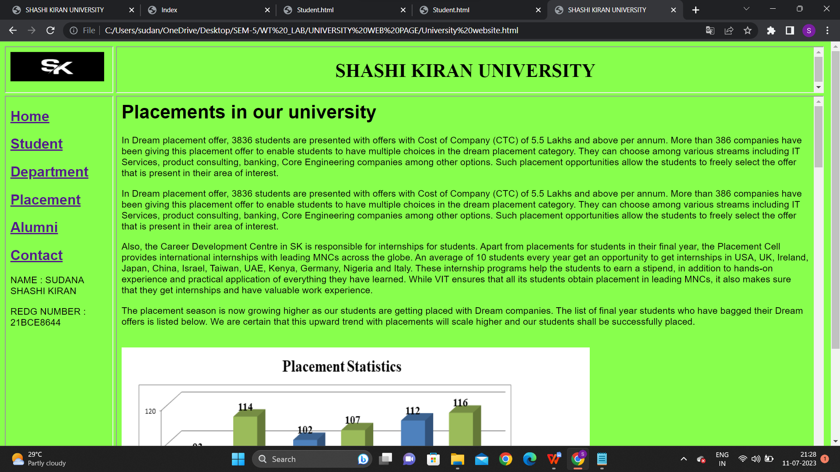

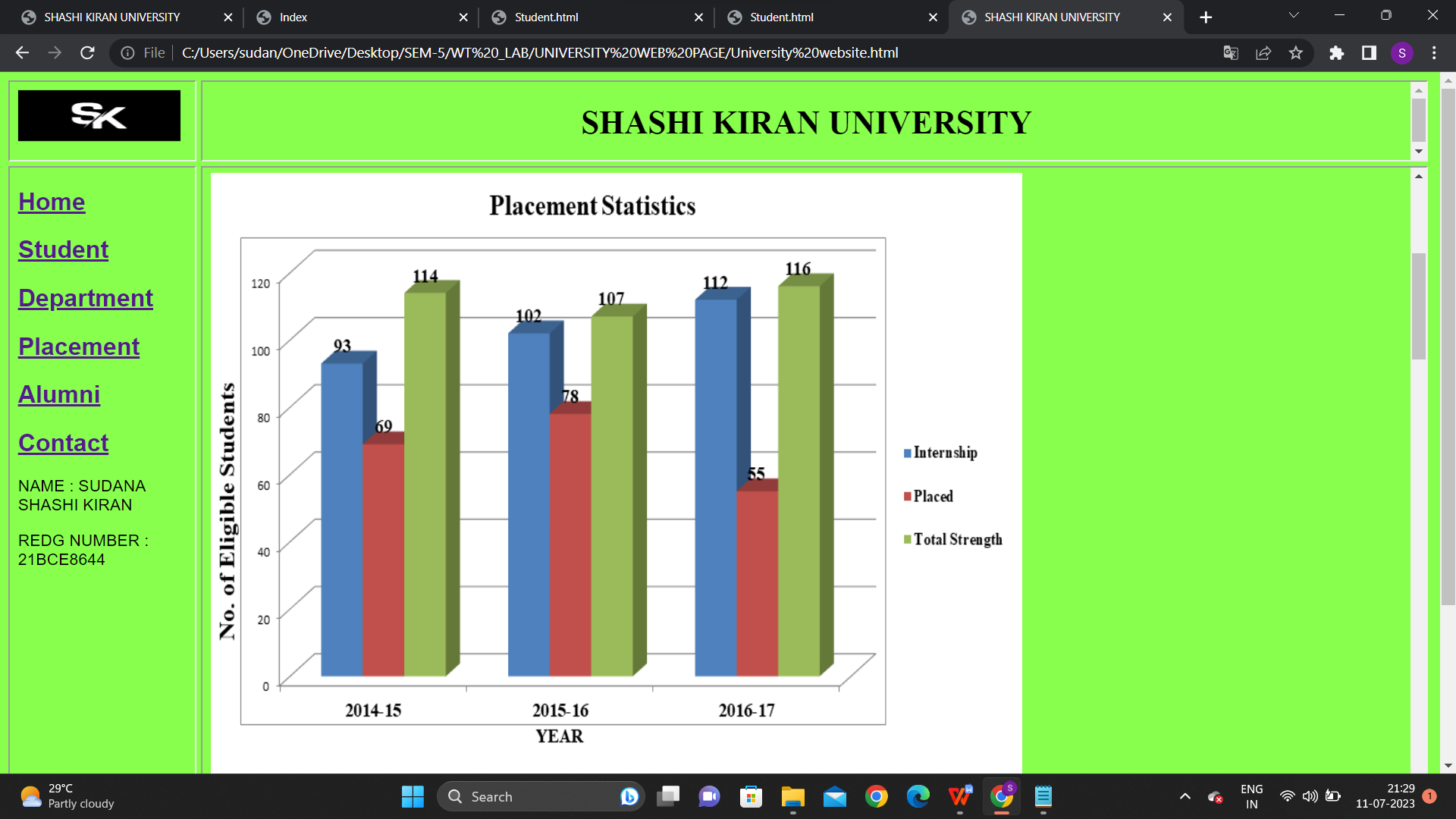

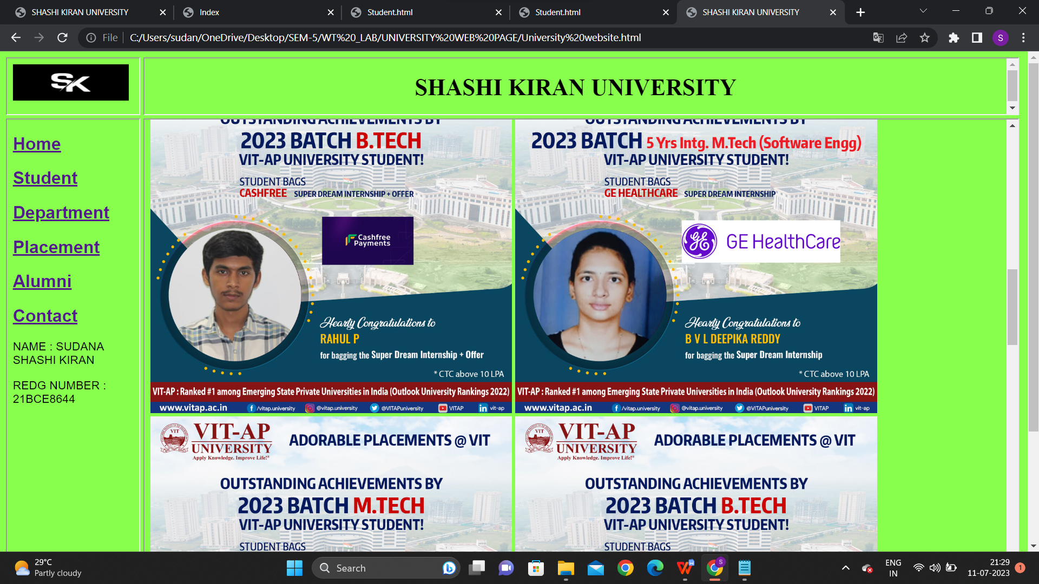

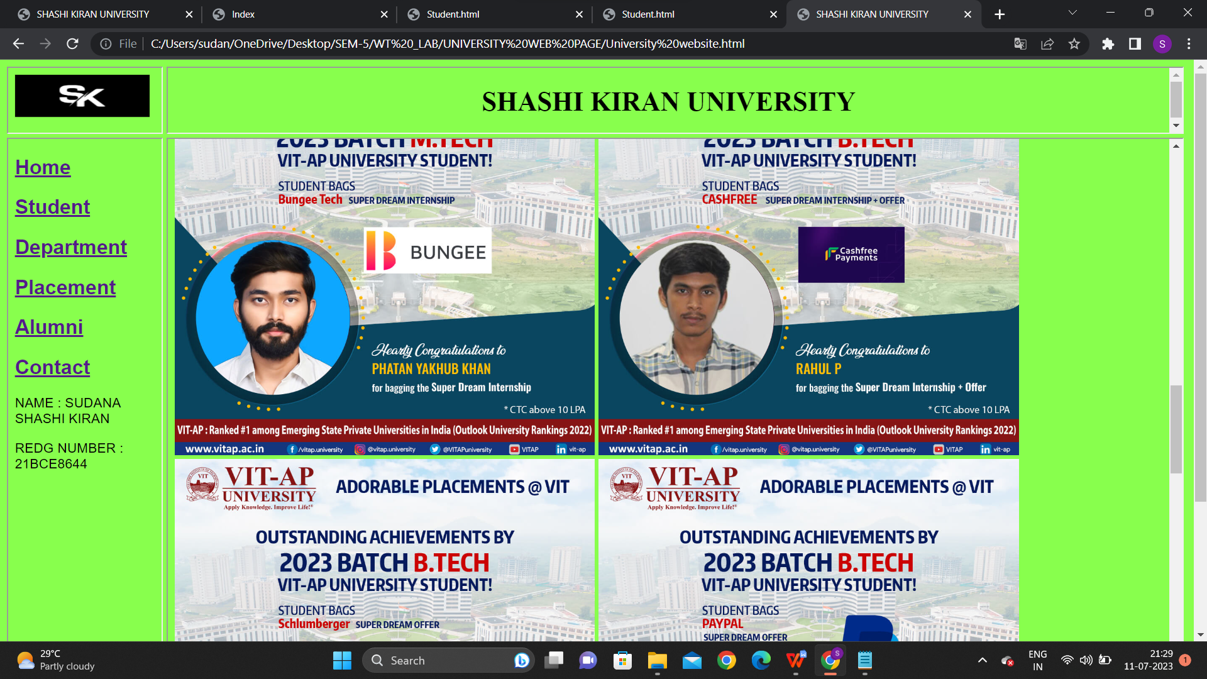

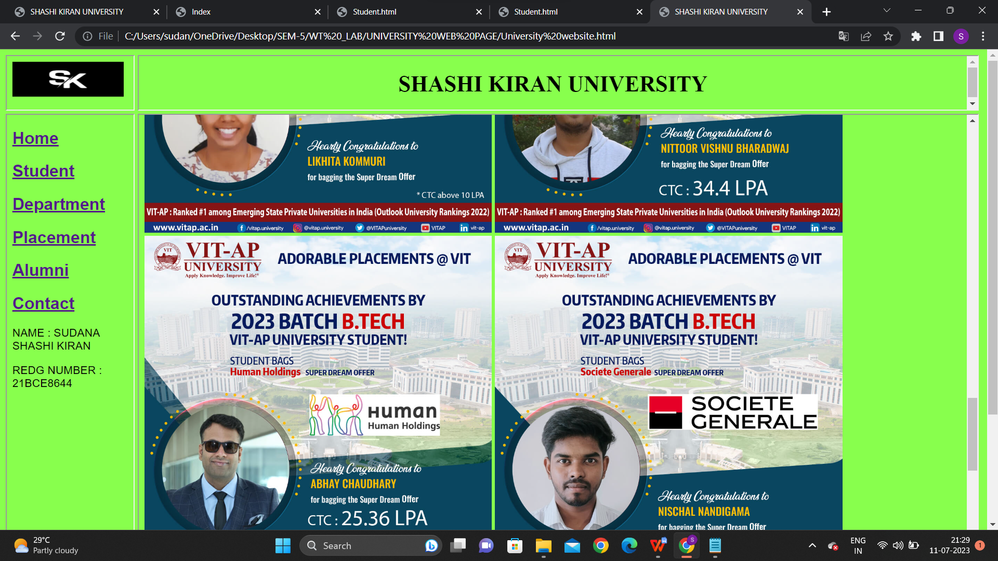

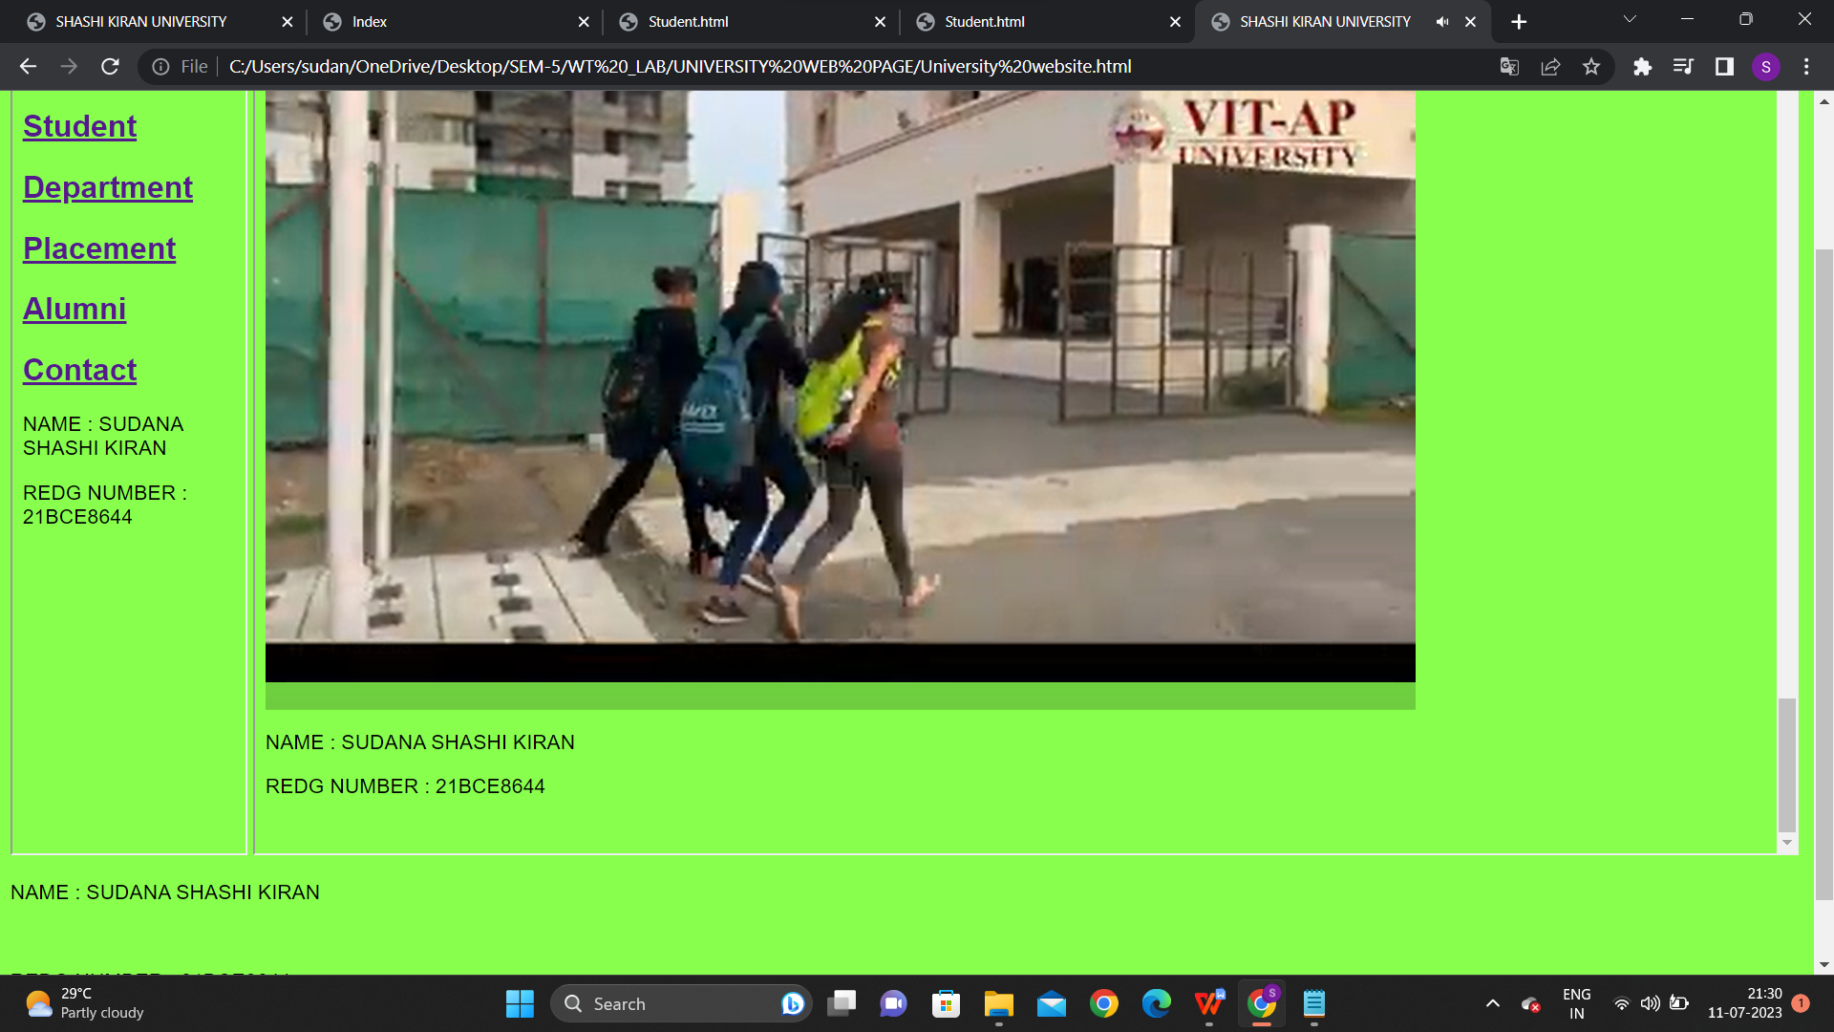

**THIS IS VIDEO .**

**CODE FOR ALUMNI:**

<html>

<head>

<title>Alumni page</title>

</head>

<h1>Alumni Affairs</h1>

<body style="font-family: Arial, sans-serif; background-color:#88ff4d;">

<b> Overview </b>

<p>The Directorate of Alumni Affairs was established in September 2017 to look after the alumni needs for the entire University. It was earlier functioning as the SKEC Alumni Office since 1996. The major objectives of the Directorate are to enhance the coordination between SK University and its alumni, to improve the interaction of alumni with the students and the faculty members, to establish alumni chapters in India and abroad, to maintain the database of alumni and to look after the interests of SK alumni.</p><br>

<b>Vision</b>

<p>Develop a fully connected, strong, SK alumni community.</p>

<b>Mission</b>

<p>Advance SK Institute of Science and Technology by promoting alumni relationship fostering commitment among students enabling student-alumni interactions.</p>

<h3>2023 Graduating Batch Students Grab Dream Offers</h3>

<img src="C:\Users\sudan\Downloads\alumni_1.jpg" alt="Placements" style="width:600px;height:400px;"><br>

<img src="C:\Users\sudan\Downloads\alumni_2.jpg" alt="Girl in a jacket" style="width:600px;height:400px;"><br>

<img src="C:\Users\sudan\Downloads\alumni_3.jpg" alt="Girl in a jacket" style="width:500px;height:400px;"><br>

<video width="320" height="240" controls>

<source src="movie.mp4" type="video/mp4">

<source src="movie.ogg" type="video/ogg">

</video>

<p>NAME : SUDANA SHASHI KIRAN </p>

<p>REDG NUMBER : 21BCE8644 </p><br>

</body>

</html>

**SCREENSHOTS :**

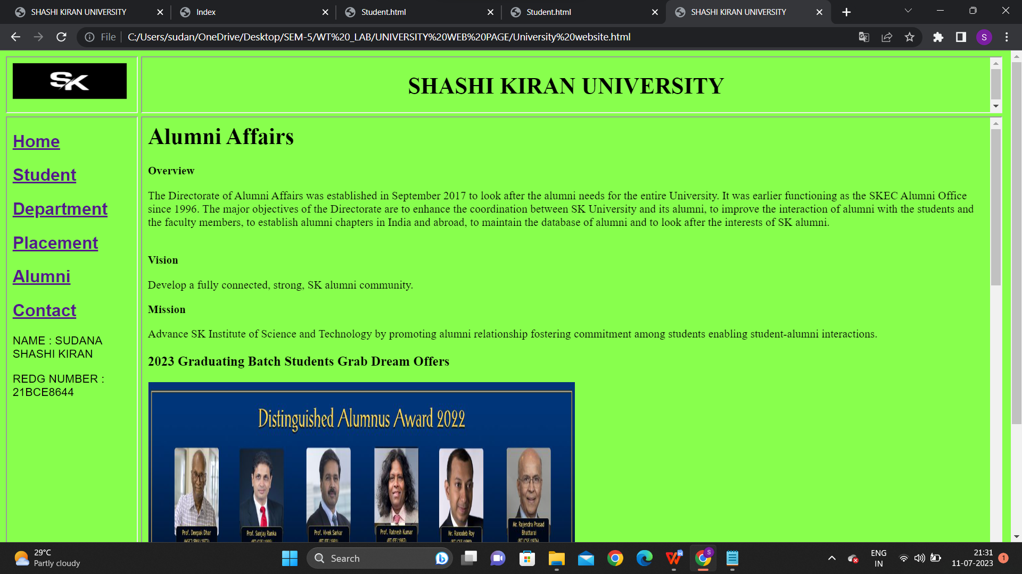

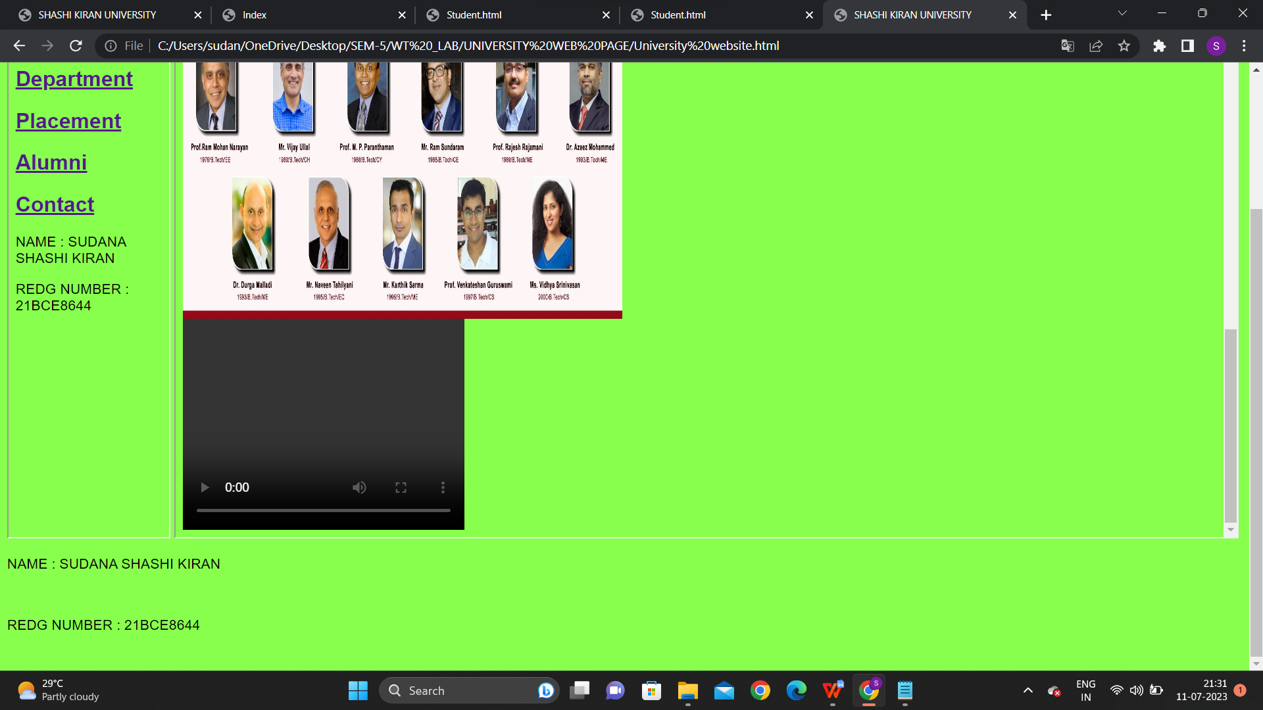

**CODE FOR CONTACT:**

<head>

<style>

.contact {

display: flex;

justify-content: space-between;

margin-bottom: 20px;

}

.contact-details {

flex-basis: 45%;

}

.contact-details p {

margin: 0;

}

.contact-details strong {

font-weight: bold;

}

</style>

</head>

<body>

<div class="contact">

<div class="contact-details">

<h2>For Admission</h2>

<p><strong>Director Admissions</strong></p>

<p>Room No. SRB-G30</p>

<p>SK University</p>

<p>(Beside AP Secretariat)</p>

<p>Near Vijayawada, 522 237</p>

<p>Andhra Pradesh</p>

<p><strong>Email:</strong> admission@skap.ac.in</p>

<p><strong>Phone:</strong> 6309844325, 8886167411</p>

</div>

<div class="contact-details">

<h2>General Information</h2>

<p><strong>The Registrar</strong></p>

<p>SK University</p>

<p>(Beside AP Secretariat)</p>

<p>Near Vijayawada, 522 237</p>

<p>Andhra Pradesh</p>

<p><strong>Email:</strong> info@skap.ac.in</p>

</div>

</div>

<div class="contact">

<div class="contact-details">

<h2>Admin. Office at Hyderabad</h2>

<p><strong>VIT-AP University</strong></p>

<p>Admin. Office</p>

<p>4th Floor, Bansal Pride Building</p>

<p>Near YSR Statue, Madhapur</p>

<p>HYDERABAD – 500 081</p>

<p>Telangana State</p>

<p><strong>Email:</strong> adminoffice@vitap.ac.in</p>

<p><strong>Phone:</strong> 040-29559555, 7901311658</p>

</div>

</div>

</body>

</html>

**SCREENSHOT:**

